Weekly Activities for Bullfinch Class 23rd March 2020

I want you to enjoy the private outdoor space you have available to you this week. The sun is meant to shine and I think you could get on with these activities without needing too much help from your grown ups! You can record any of these bits in your new workbooks. Don’t forget a short date.

- We have been comparing our locality to Kenya and looking at similarities and differences. Can you remember the photos we shared in Geography? Have a look around your garden or outdoor space – how do you think it is the same to outdoor spaces in Kenya? How do you think it is different? Can you draw a picture of what yours looks like? Maybe you could draw what you think it looks like in Kenya. Some of you could write and make a list. Put a title at the top of your page and think about the similarities and differences.

- Can you be a scientist and dissect a flower from your garden? You might find one out on a walk. A daffodil will work best for this activity. Check with your grown up that its ok to pick it first though! If you carefully use scissors to take apart each piece of the flower you should be able to find all these parts.

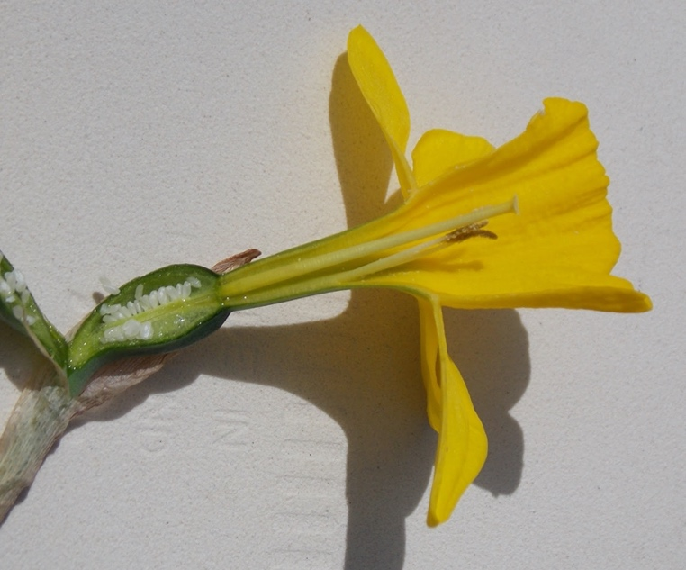
Can you take each part off carefully? Have a go at sticking each piece down into your workbook. Can you label any of the parts? These words might help you; petal, stem, sepal, trumpet, eggs. There are lots of other parts that you might be able to label with the help of a grown up or an information book.

- Be a detective and go on a minibeast hunt. See what insects you can find in your garden. Remember they all have 6 legs – can you find anything with more legs? Don’t forget to leave them in their natural habitat, but you could make a tally of what you find or even draw some of them!

- Can you think about all you are grateful for right now – has the sun shone on you and warmed your face? Have you been able to play outside with someone? Have you found beautiful flowers in your garden or when out on a walk? Did you spot some creatures when you were being a minibeast detective? Could you write a prayer to say thank you to God for these things? Share it with your family.

- See if you can log onto purplemash and have a go at making a new avatar to express yourself. If you’ve done this or don’t want to change your current one, you could carry on with your animated story. See if you can add a new page of the story. Once you’ve logged in you go onto Work – My Work and it should be saved there. For those people who haven’t yet started one you need to go to Home/English/2 create a story/my simple story.

