The Itsy Bitsy Spider Paper Craft
You will need:
Glue
Scissors
Itsy Bitsy Spider Cut-Outs
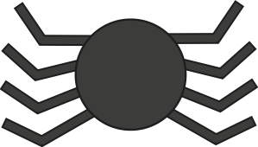
Instructions
1. Print out the Itsy Bitsy Cut-Outs.
2. Cut out all the body pieces.
3. Fold each of the spider’s legs in a fan motions to create a crinkled effect. 4. Glue the spider’s head and body together.
5. Glue four spider legs on each side of the spider’s body.
visit twinkl.com

Itsy Bitsy Spider’s Legs


