Topic Activities Week Beginning 18.5.20

This week it’s Mental Health Awareness week so all your extra activities are based on this. It’s always important to talk about your feelings and to do things that make you happy and allow you to relax. Have a watch of the PowerPoint that’s on our class page, then have a go at some or all of these activities.

DT
Can you design and build your own fort/den? It’s great to escape to a world of make believe…
Ikea have come up with some great designs.
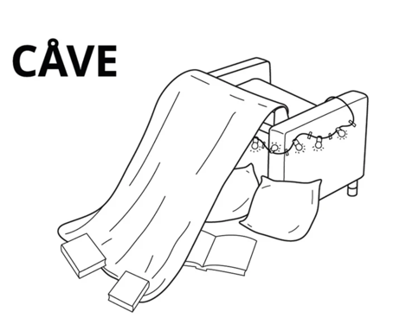
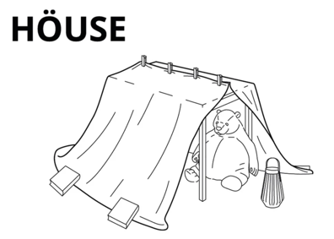
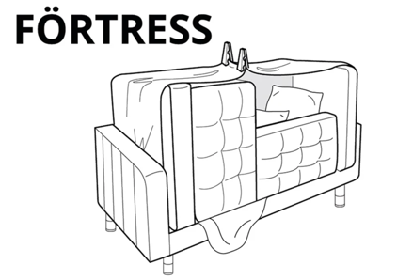
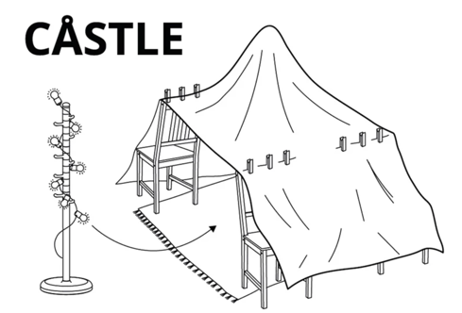
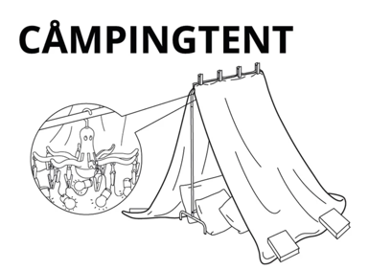
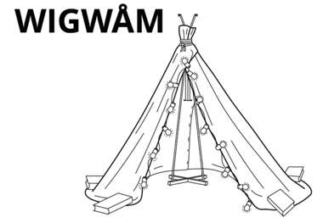

Follow this link for further details of what you might need to help with your design https://www.designboom.com/design/ikea-furniture-forts-05-14-2020/

Art
Did you know that you are UNIQUE? No one in the world is exactly the same as you. Everything about you is SPECIAL and MUCH LOVED - Can you look in the mirror and think about all the physical features that make you, you? Have a go at drawing or painting a self portrait. Can you get it right first time or will you need a few goes? I’ve also attached a link on our class page for some mindfulness colouring sheets you might like to have a go at too.

Science
See if your grownups can print off a photo of you that shows your whole self from the top of your head right down to your feet. (Draw a picture or stick person of yourself if not). Can you label the parts of your body? These words might help you.

Head | Hand | Shoulder | Neck | fingers
Wrist | Knee | Ankle | Foot | tummy

Have a go too at writing the things each body part is good at – maybe your mouth is good at saying kind things to friends and your feet are good at running. Perhaps your hands are good at drawing and your eyes are good at looking for people who might need your help!

PSHE
Do you know that you have a skillset specific to you? There are things you are brilliant at that other people might struggle with. Can you think of things that you can do well? Maybe it’s riding a bike, being a good friend, counting to 20. Have a chat with people in your family about those things. Are there things that you’d like to do better? You could write a list using the proforma on our class page.

ICT
Have a look at the 2 dos on Purple Mash. There’s ‘Human Body Labelling Game’, ‘My Body’ and ‘All About Me’
You might choose just one or do all three!

