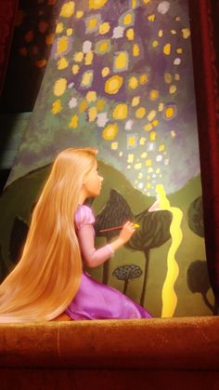
Rapunzel is locked in her tower with only her Mother (The Witch) for company. She longs to see other people.
- Draw a picture of who you are at home with and who you look forward to seeing soon.
- Write words and sentences to explain your pictures.
Challenge 2: ‘Locked’ in your tower with...

Rapunzel has been very busy in her tower painting, reading, learning and playing. Her tower now has beautiful paintings on the walls, a snug reading den, a play area and desk for her to learn.

- How has your house changed?
- Take a photo or draw pictures of how your house has changed since being at home. Label your photos and pictures or write sentences to explain them.
Challenge 1: How has your ‘tower’ changed?

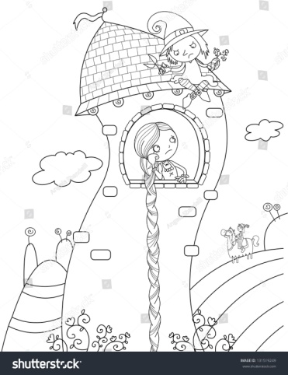

Literacy- Rapunzel
‘The Princess of Lockdown’

Challenge 3: How do you feel?

Challenge 4: Your Family Tree

Rapunzel decided to draw a family tree but she sadly realised she didn’t know any of her other family except from her mother. Rapunzel shouldn’t worry though, as everybody’s families are different! Some are small and some are large.

- Draw or make your own family tree. Remember to label everybody’s names (Don’t forget capital letters for names). 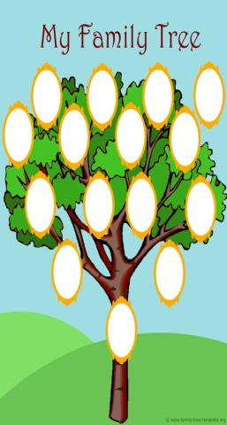

Which sculptors created them? What are they called?

Since being locked away, Rapunzel has been feeling lots of different emotions. She has been happy whilst playing and painting but she has also felt sad because she feels a little lonely.
- Draw, make, create or paint your own emojis to explain how you have been feeling whilst at home. Talk to your loved ones about how you feel...it’s good to talk.


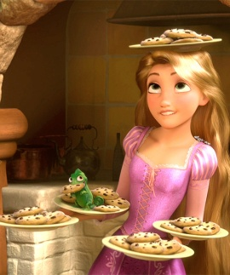
Write a letter back to Rapunzel to tell her all about how you feel, what you have been up to and what you are missing since being ‘locked’ away at home.
A letter template is attached; you can decide which one to use.
(If you can, email your letters to Mrs Metcalfe and Mrs Crowe and they will send them to her.)

Final Writing Task:

Since being locked away, Rapunzel has really enjoyed making lots of memories like playing, painting, baking, singing and dancing. She’s been keeping a photo journal of everything she’s been up to, to help her remember all the fantastic memories she’s made.
- What memories do you already have of your time at home? What are your favourite memories so far? How are you recording your memories?
- Maybe you could take some photos and email them to us or make a scrap book or even write a short story about your time at home.

Challenge 5: Memories of Lockdown

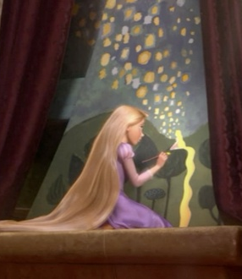

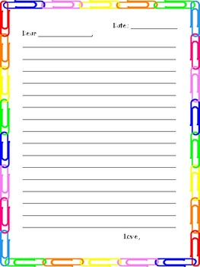
Literacy- Rapunzel
‘The Princess of Lockdown’

Extra Challenges you might like to try:

- Have a movie night and watch Disney’s Tangled. How is it the same or different to the story?
- Make up a new game for Rapunzel to try whilst she’s locked away in the tower. Write some instructions on how to play it.
- Paint a beautiful picture of what you can see out of your window.

______________________________________,

__________________________________,

I am writing to____________________________

I have been feeling _________________________

During my time at home I have ________________

I am really missing _________________________

________________

__________________

Dear ______________,

I am writing to tell you all about my time at home.
I have been feeling _________________________

During my time at home I have been_____________

I am really missing__________________________

But I have really loved______________________

_______________________________________

__________________

