Bubble Activities – Week Commencing 1.6.20
As we welcome some children back to school this week, we will thinking about bubbles and how we have to become part of a safe one at school! Here are some activities all about bubbles for you to have a go at.
If you’re a year 1 coming into school this week then we will hopefully be having a go at the Art/DT, PSHE and the printing. Feel free to have a go at home first though!

How to make bubble mixture
- 1 litre hot water.
- 250ml good quality washing up liquid.
- 2-4 tablespoons of glycerine. (optional)
Best made 2-3 days in advance.

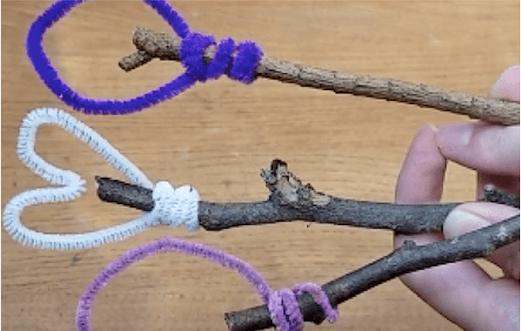
Art/ DT
Make your own bubble wand. Try using:
- Pipe cleaners
- Sticks and coated wire
- Sticks and string
- Cookie cutters and sticks
Which were the best materials to use? Why?
Decorate your wand with paint, tissue paper, beads etc.

Bubble Printing
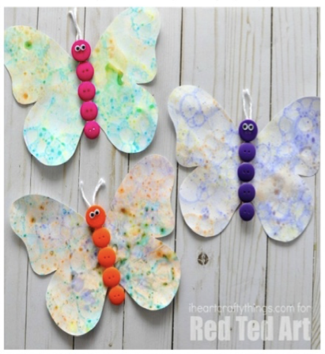
- Pour bubble mixture into 3/4 small lidded containers. . - Add food colouring.
- Shake up the containers to froth up the mixture.
- Place card over the tops to take on the bubble print

You can cut your card into animal shapes and decorate if you like.

PSHE
Talk about the idea of personal space and about how, at the moment, our personal bubbles need to be bigger than usual to keep us all safe from the coronavirus. Think about who you will soon see with lockdown rules relaxed. Will you and your family meet with a few other people in a bubble of six in your gardens or nearby parks? Who are you most looking forward to seeing?

Science/ Understanding the World
Questions to prompt children to explore/ experiment with bubbles:
Can you make bubbles just with water? Do bubbles last longer in the shade or in the sun? On a dry surface or a wet surface? Do bubbles make shadows? What colours can you see in a bubble? Can you make a pointy bubble or a cube- shaped bubble? Can bubbles go underwater? Are smaller bubbles always stronger than bigger bubbles? Could a person float inside a bubble? Why/ why not?

