Topic Activities for Week Beginning 8.6.20

All the ideas are around the theme of pirates to fit with our Talk 4 Writing Unit. You might decide to do some investigating and exploring of your own on this theme too as you don’t have to just stick to these ideas and activities. Keep sending your photos in to share with the class.

Art – We will complete this activity at school for those who are coming in on Wednesday, Thursday and Friday

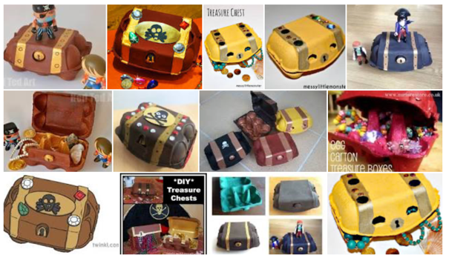
Take an egg box and see if you can make it into your very own treasure chest. You might paint it or colour it in. Add some jewels onto it and then fill it with your own little treasures.

Dance/PE
Have a listen to the piece of music on our class page that’s called “He’s a Pirate’ You will probably recognise it – Can you move in the way a pirate might? Imagine you were under attack on your ship and trying to protect your treasure.

There’s also a link to a song and dance on CBeebies. Can you follow it and move in the same way they do?

Geography
Every country has a flag by which they can be identified. Can you research the flags of England, Wales and Scotland and have a go at drawing them?

Every pirate ship would have had a flag to identify them. Can you design your own pirate flag? You might even make one for your house or to put in your garden.

ICT
There are 4 2dos set for you on Purple Mash. Two link to our pirate theme, there is a fish counting one and then one linked to the Geography flag work.

Science
Have a look at the link on our class page. Can you see which pirate treasure might sink or float. There are some extension activities on there too.

