Curriculum Activities – Rainbows have been a very prominent feature during this time. Have a go at the following activities and do your own research too – see where your learning takes you.

Art
Have a go at the Rainbow Treasure Hunt Outdoor Trail – What can you find to stick for each
colour? The link is on our class page.

ICT
Go to www.ictgames.com and have a look through at the English and Maths games. You will have had a go at Save the Whale and Counting Caterpillar for your maths work. Are there some other games you might like to play?

There’s one Purplemash 2do set for you too.

PE/Dance
There’s a recent craze called the Rainbow Floss – Can you do it? Watch the moves on the link from Newsround. Set yourself a challenge to see how long you can move for. Does it get your heart pumping faster? Send in a video of you doing it if you can!

Science
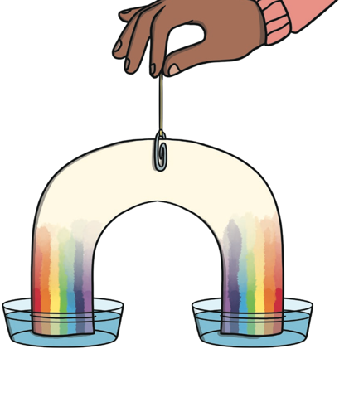
See if you can make your own rainbow using kitchen roll, felt tips and water. There are some big words to learn too about this process!

You can watch the Go Jetters episode about Rainbows that I’ve linked to the page too.

PSHE

Have a look at the attachment on our class page called PSHE Bubbles of Gratitude. As you colour each bubble, think of something that you are grateful for. It could be something big or something very small, something that you experience often or something that has just happened once. Thinking of these things helps make us feel calm and happy.

