KS1 Music Adventure

This week’s singing is all about the sea. introducing clapping rhythms and a crocodile!.


Here’s this weeks link: https://www.bbc.co.uk/teach/school-radio/music-ks1-sun-sea-song-5-a-sailor-went-to-sea-sea-sea/zrktxyc

Week 5 : Singing : A sailor went to sea, sea, sea

- Practise singing ‘sea, sea, sea,’ very clearly with a strong ‘S’ sound.
- Practise the ‘slow, slow, fast, fast, fast,’ clapping.
- Practise the rowing actions in ‘Row, boys, row’. Do it in time to the music.
- Spot how the second verse of ‘Row, boys, row’ is different to the first verse. Which words change?
- Can you remember the actions we have done in class? Can you do these actions on the following words?
Sailor / He – hands holding imaginary braces.
Sea – hand to your brow looking into the distance
Bottom – point to the floor
Can you sing the song and do the actions?
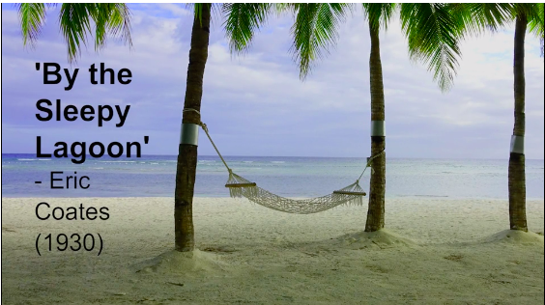

Activity 2.

Listening music: 'By the Sleepy Lagoon' (composed by Eric Coates, 1930)
- What are the dynamics of the music? (It is quiet and calm.)
- Is the music fast or slow? (It is slow and has a relaxed feel.)
- What does it make you think of? Listen again, and tell a grown up your ideas.
- Can you imagine the sea lapping gently against the beach and the wind rustling softly in the trees?
- This piece of music is called ‘By the Sleepy Lagoon.’ A lagoon is a sort of sea lake. Do you think this is a good title for the piece?
Suki and Nigel arrive at Golden Island and Find a cave...do you think they should go in...?

