Chaffinch Topic Activities for Week Beginning Monday 27th April 2020
Here are some activities you could work on over the week, once you have tackled your maths and English tasks (remember your spellings and x tables too). Please let me know what you liked or didn’t enjoy so much and send some photos on the parents email.
maths    Complete the task to support your daily maths and ‘Hand In’ . | I like reading your ‘hand in’ comments, so please keep me updated.  Y4  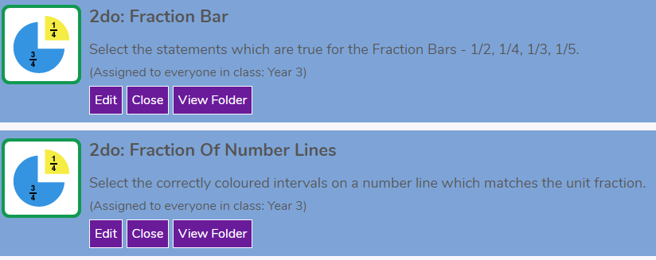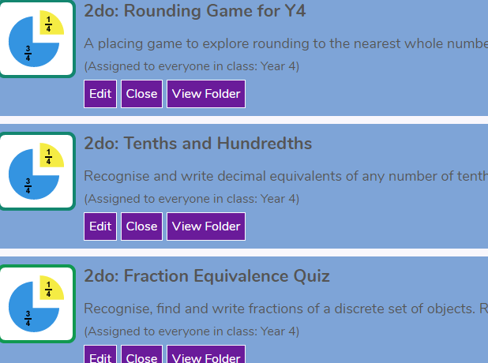  Y3
French   | https://www.duolingo.com/course/fr/en/Learn-French  You should aim to complete at least 2 levels a day which will take about 5 minutes. Or listen to a book in French like Peter and the Wolf  https://stories.audible.com/discovery/enterprise-discovery-21122523011?ref=adbl_ent_anon_ds_ds_dccs_sbtp-0-8
PE   | https://www.nhs.uk/10-minute-shake-up/shake-ups  These short bursts of fun activity may be just what you need to break up your learning. Why not try one with a family member?  (I don’t think Toy Story will work as you need a swimming pool!) Id love to see some photographs on email.
Science  electricity   | - https://www.bbc.co.uk/bitesize/topics/z2882hv/articles/zcwnvw9q  - 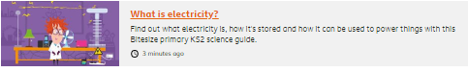  - Watch the short clip then play the game. Finally, look around your home and see if you can sort the electrical items into those that produce light, sound, movement or heat. How can you show your findings? Do any produce more than one type of energy? Next week we’ll look at insulators and conductors.
Geography  maps | https://www.bbc.co.uk/bitesize/articles/zkngrj6  learn how to read a map and use a compass. There are two videos demonstrating how to use a map and two activities to help develop map skills – you can do the second activity without printing out the twinkle sheet. Just do it in your exercise book.
PSHE/wellbeing   | https://www.bbc.co.uk/bitesize/articles/zbcthbk  teamwork – why it’s important to work together. What teams are you part of right now? I’m part of my team Dodds’ family, my teach chaffinch family and my team teachers family. Watch the video then think about your team skills and how you can best use them.

