Chaffinch Topic Activities for Week Beginning Monday 4th May 2020
This week we have 4 days of learning planned to fit with Friday’s BH. You should have received 2 emails last week with your child’s login details for TTRS and ReadTheory. Both these are great for daily practice if you have easy access to the internet. If not, good old-fashioned reading and pencil x table practice is great too. English activities are over two weeks from 27.4.20 and there’s the optional Europe project too. Please let me know what you liked or didn’t enjoy so much and send some photos on the finchparents email.
VE Day  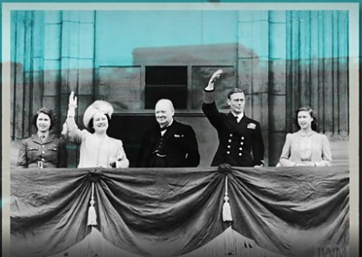 | https://www.bbc.co.uk/teach/class-clips-video/history-ks2-ve-day/z7xtmfr  Watch this short film on the bbc website then look through the British Legion VE powerpoint. The resources are specially designed for home learning. They are aimed at 7-14 year olds and include family-friendly activities. If you display it with the notes pages showing there is useful support for talking to your child/children about VE Day and Remembrance. As well as the listed activities can you write a short prayer and share it ahead of Friday via the finch parents email so we can share with our school community.
Maths 4th and 11.5.20    Complete the task to support your daily maths and ‘Hand In’ with a little comment. | Y4 - In support of your work on money next week, you will need to use column addition and subtraction. If you want a quick reminder, look at these teaching videos and practice examples: https://www.bbc.co.uk/bitesize/articles/z6vr47h https://www.bbc.co.uk/bitesize/articles/zrtsy9q  Y3 – telling the time is difficult. Look on education city under maths and measure to find some games about time. These two are good for starters: 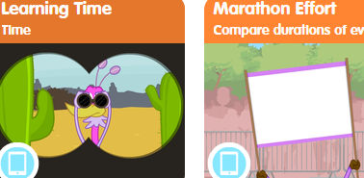  Y3 and Y4 also have optional 2Dos set in purple mash to support your learning on either time or money – these will cover the two week maths units.
PE   | https://www.youtube.com/thebodycoachtv  Back to thebodycoach this week – or a walk / run/cycle of course.
Science  electricity   | - https://www.bbc.co.uk/bitesize/topics/z2882hv/articles/zxv482p  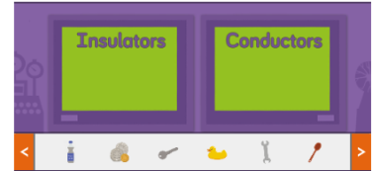  - Watch the short clip then play the game. Finally, look around your home and see if you can find three things that could be an insulator and three things that can conduct electricity. How are materials used on electrical items? Does anything surprise you? Why? Record your findings in your exercise book with a clear date and title. Next week we’ll look at power.
Geography  maps | https://www.bbc.co.uk/bitesize/articles/zjdm6v4 contours, keys and symbols  Sue Venir (love this name!) is celebrating her friend's birthday with a camping trip. Her friend has given her a map so she can find her way to the campsite. Watch this short film to find out how she uses contours, keys and symbols to read the map. The activities at the end look fun, especially making your own contour island if you can find cardboard. I’d love to see what you’ve made .
RE  Parables  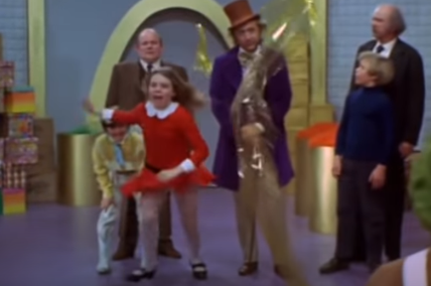 | Please look through the powerpoint talking about how Jesus used stories in his teaching. Then watch this short clip where a modern day story has a message for living life well. What is the message? Can you write / act out with lego or toys your own story with a message? What will it be about greed? Selfishness? Truth? Patiece? Kindness?  http://www.youtube.com/watch?v=TRTkCHE1sS4

Other useful websites used before - if you would like to revisit:
https://www.duolingo.com/course/fr/en/Learn-French
https://stories.audible.com/discovery/enterprise-discovery-21122523011?ref=adbl_ent_anon_ds_ds_dccs_sbtp-0-8

https://www.nhs.uk/10-minute-shake-up/shake-ups

https://www.nssport.co.uk/News or https://www.facebook.com/NextStepSport/videos/1877282162403069/

