Chaffinch Topic Activities for Week Beginning Monday 18th May 2020
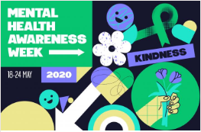
This week is mental health awareness week, with a special focus on kindness: to yourself and to others. We would like your afternoon activities to focus on this theme and have linked to Scince, PE and PSHE. Your daily English and Maths lessons continue as usual and please can you try to practice your spellings, times tables and reading skills each day. English activities are over two more weeks from 18.5.20 – with a break for half term - and there’s the optional Europe project too. How will you show KINDNESS this week?

Maths  There are lots of time activities in the to do section this week for those who need extra practice.   | Purple Mash and Education City – keep going with the overlearning of time using the games under TO DO or your year group, Measure and Time. The more practice you have of telling time in everyday situations the better. Can you look online at train or bus timetables and work out the duration of journeys? As a challenge – convert longer time intervals into minutes of even seconds. Challenge: make up questions to solve such as..Which is longer…5 hours, 200 minutes or 10,000 seconds? How many minutes in a day? How many seconds in a week? Daily Times Tables on TT Rockstars, the app below or purplemash. Choose your favourite.
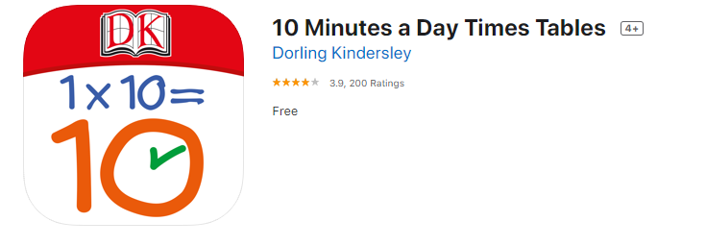 | If you’re finding TT Rockstars difficult, or just want a change, the app we use on our school tablets in Chaffinch class is a useful alternative and free to download. Dorling Kindersley.
PE   | Please see the options on Your Amazing Brain word document on our class pages and/or choose from the previous activities shown on the websites below.
Science  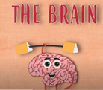 | - Watch the animation and answer the questions about your brain. Can you design a poster or information leaflet to explain the key facts about the brain? Maybe do some of your own internet research to find out more key facts to include.
Geography  Longitude, latitude and hemispheres   | Learn about latitude and longitude including the equator, hemispheres, prime meridian and Greenwich meridian. This lesson includes: one animation explaining latitude and longitude, one animation describing how the pilot Amelia Earhart used latitude and longitude, two activities to build knowledge.
PSHE  Kindness | Kindness is a key value at school and an important part of everyday life, family and society. Try some of the activities on the Your Amazing Brain worksheet to be kind to yourself and others. Think about what’s happening in your world today and answer these questions in your book: How has a family member been kind to you today? How have you been kind to yourself? Who else have you been kind to and how? Why does being kind matter?

Other useful websites used before - if you would like to revisit:
Times tables rockstars: https://play.ttrockstars.com/ and ReadTheory: https://readtheory.org/auth/login are great for daily practice if you have easy access to the internet.
French:
https://www.duolingo.com/course/fr/en/Learn-French
Stories:
https://stories.audible.com/discovery/enterprise-discovery-21122523011?ref=adbl_ent_anon_ds_ds_dccs_sbtp-0-8
http://www.read.gov/aesop/001.html - great collection of Aesops short tales to read and talk about
PE:
https://www.youtube.com/thebodycoachtv
https://www.nhs.uk/10-minute-shake-up/shake-ups
https://www.nssport.co.uk/News or https://www.facebook.com/NextStepSport/videos/1877282162403069/

