Creative Ways for Chaffinch to learn to tell the time

LEGO® Time!
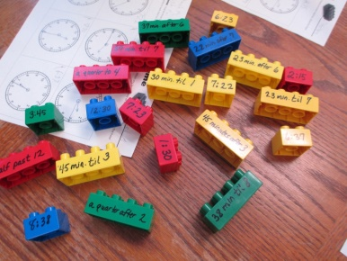
Take some of old LEGO or DUPLO® blocks and create sets to practice the idea of minutes before the hour, and minutes after the hour. Match together the digital times with the correct wording. Eg 06:20 links with twenty past six an so on. Tip: The permanent marker comes off the plastic easily with just a little Liquid Soap
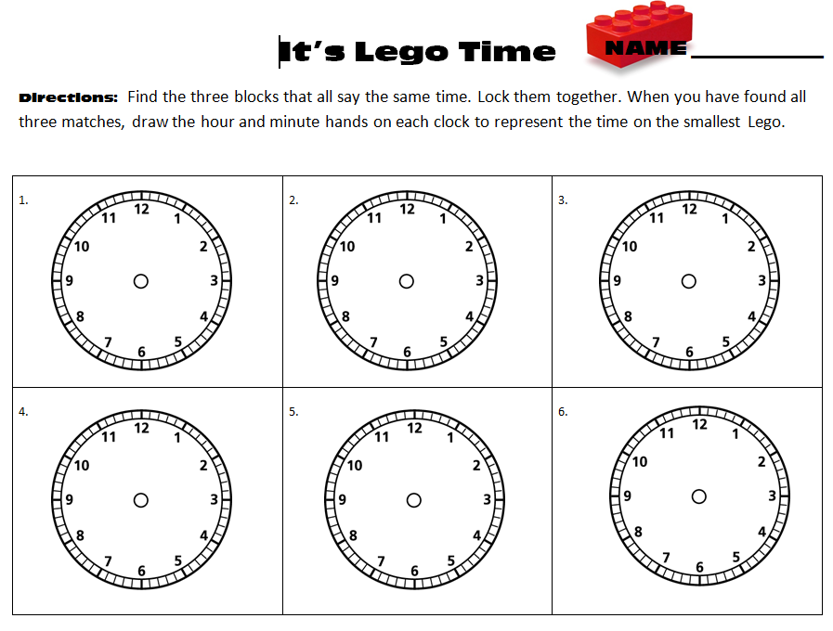
See below for blank legotime sheet
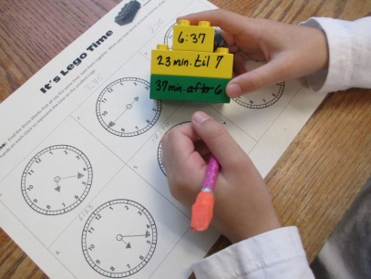

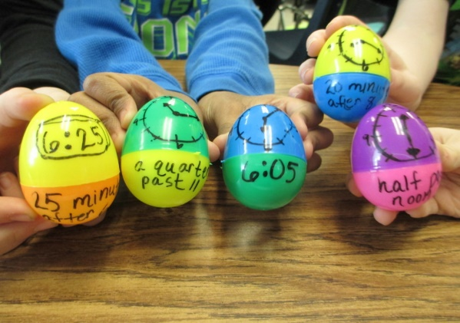
A similar idea – use what ever
You have at home.

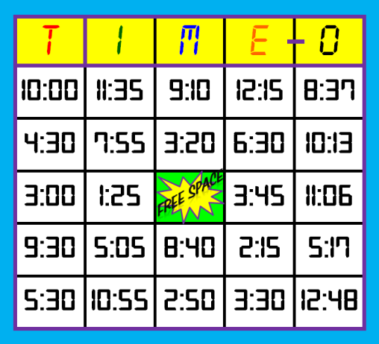
Time Bingo
Can you make a Bingo-style game to play? Depending on the confidence level of the children playing, you can change the way you say the time as you call off numbers. For example, instead of just saying 6:30, I might say half past six. The time of 8:37 could be read as 23 minutes before 9.

Real Life Elapsed Time Word Problems
For many children, of all the things we do in our measurement unit, calculating elapsed time always proves to be the most challenging. Extra practice can help with made us stories. For example, one problem might be:
Mrs. Dodds is cooking lunch for Chaffinch Class. She can only do one job at once. The chicken nuggets will take 37 minutes to cook, cutting the watermelon takes 22 minutes, and it will take her 9 minutes to pour the lemonade. She wants everything finished at 12:20 p.m. What time should she start each item?

Apps and Websites for Time Practice
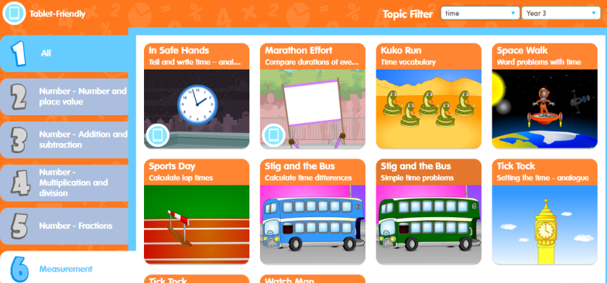
Education city – Year 3 Unit 6 select 6:measurement then filter on the top bar for ‘time’ and there are lots of really useful games and activities to hep ‘over learn’ the key ideas for time.

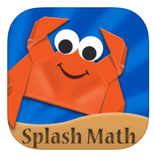 | Splash Math 3rd Grade is an interactive workbook with 16 chapters covering math topics found in the Common Core State Standards for third graders. Time and measurement are both reviewed as well as all other areas of math. Splash Math is available in other grade levels as well. Free, with in-app purchases available.
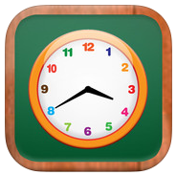 | MathTappers: Clockmaster is a game to help children make the connection between hours and minutes and to help them become fluent in both reading and setting time on digital and analog clocks. Free.



