RE week commencing 15th June 2017
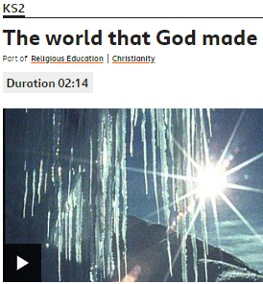
https://www.bbc.co.uk/bitesize/clips/ztmpvcw watch this short video about the Christian Creation Story - how the earth was made. It shows the wonderful elements of our world – including the rocks that you’re learning so much about. Christians believe that God is the creator of everything. You can use this clip to springboard your own ideas. How would you like to respond to it?
You could:
Draw, paint or collage some of the wonderful things shown in the clip.
Read and discuss the bible story in Genesis about the world’s creation.
Write a prayer to thank God for the wonderful world.
Reflect on the images and find out more about each one – where is the world biggest volcano, highest mountain, deepest ocean etc ?
Think about how much you care for our wonderful world and how you can help to protect it. Write your name in the middle of a sheet of paper and surround it by words and phrases to do with aspects of creation that you can influence. Eg don’t litter, use less plastic.
OR something entirely different – the choice is yours.

