Jude’s Treasure Hunt Images
1. Horizontal Lines

2. Parallel Vertical Lines
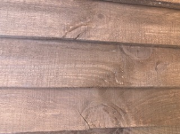
3. A Compound Object
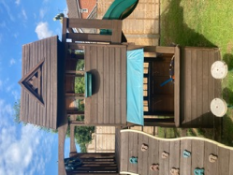
4. Objects with an acute, obtuse and right angle
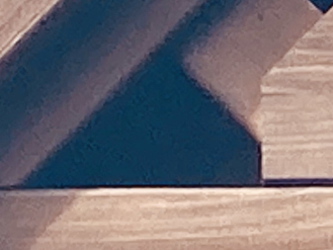

5. Object with 2 lines of symmetry
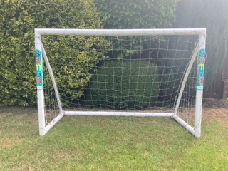
6. different triangle shapes
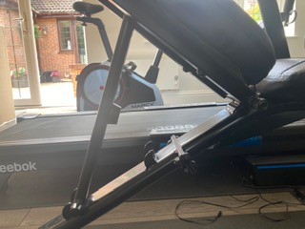

7. An irregular hexagon
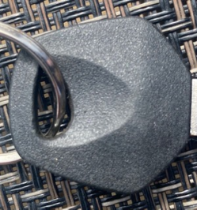
8. An irregular pentagon
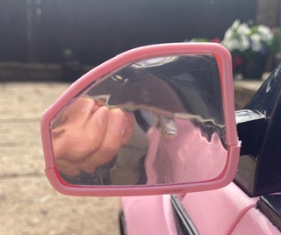
9. An irregular quadrilateral

10. Jude’s interesting shape is an Isosceles Trapezoid. Jude likes this shape as its different from the others above and it has many types of different shapes across and within the structure. It also keeps us warm at night when we have friends visiting allowing us to play in the garden. Jude also thinks the image is 3D, So pretty cool.
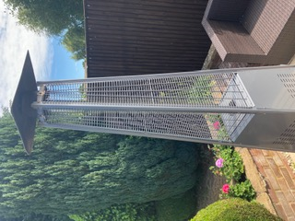
Jude is wondering if anyone else in his class found a 3d Isosceles Trapezoid too?

Jude Hagan-Grenfell
Chaffinch Class
Finchampstead Primary School

