https://www.youtube.com/watch?v=qED4kWgkrUs

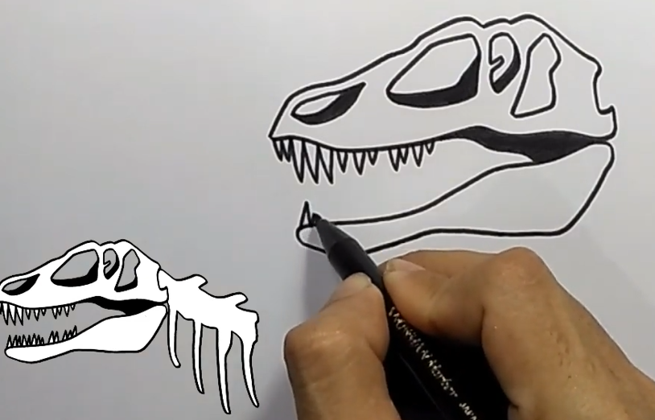

https://www.bing.com/videos/search?q=How+to+Draw+a+Simple+Fossil&&view=detail&mid=D7132A40695E24E2824FD7132A40695E24E2824F&&FORM=VRDGAR&ru=%2Fvideos%2Fsearch%3Fq%3DHow%2Bto%2BDraw%2Ba%2BSimple%2BFossil%26FORM%3DVDMHRS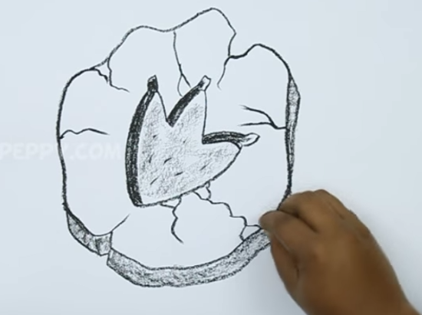https://www.bing.com/videos/search?q=how+to+draw+a+ammonite+fossil&&view=detail&mid=2D1376AC8419071C434F2D1376AC8419071C434F&&FORM=VRDGAR&ru=%2Fvideos%2Fsearch%3Fq%3Dhow%2520to%2520draw%2520a%2520ammonite%2520fossil%26qs%3DSC%26form%3DQBVR%26sp%3D3%26pq%3Dhow%2520to%2520draw%2520an%2520ammonite%26sk%3DAS2%26sc%3D3-23%26cvid%3D2B0F36AF96B3412098873738F9E950CD



