22.06.2020 Chaffinch Weekly Spellings
Last week was the last week of the spellings from your handwriting / spelling folder.
If you’re a little behind with completing each week then please use this week as a ‘catch up’ week.
If you managed to complete a new ‘pattern’ each week, then your challenge for this week is to look over all the hard work you’ve done and select a pattern that you’re not as confident with to re-learn. Remember to use all the ideas we use in class to help you embed the spellings e.g. rainbow or pyramid writing. (There’s a list of ideas on our class page from the 22nd March 2020)
How is your handwriting? Nice and even sized letters and cursive?
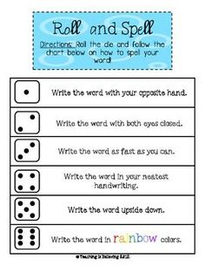
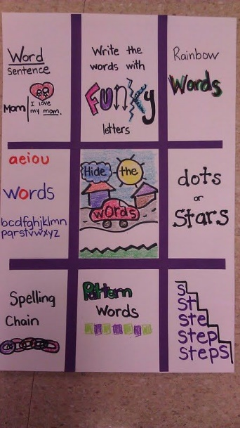
Next week I will post, on our class page, a list of all the spelling patterns / words from the national curriculum for Lower KS2 (Y3 and 4). This includes all the spellings we’ve covered this year and will be a useful summary. I’ll also post the Upper KS2 list for Y5 and 6 so those of you moving on to Goldfinch in September can see your targets. This is for information only but some of you may be interested to see where your learning will take you…

