Chaffinch Spellings – Summary of the year

A list of all the spelling patterns / words from the national curriculum for Lower KS2 (Y3 and 4) is now posted on our class page. This includes all the spellings we’ve covered this year and will be a useful summary.

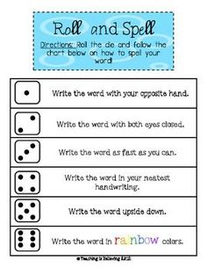
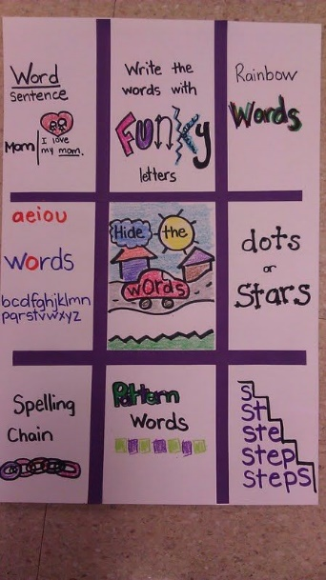
You may wish to check your learning so far and perhaps revisit those words or patterns you find difficult.
I’ve also posted the summary for KS1 (Y1 and 2) as revision and the Upper KS2 list (Y5 and 6) so those of you moving on to Goldfinch in September can see your targets. This is for information only but some of you may be interested to see where your learning will take you…

