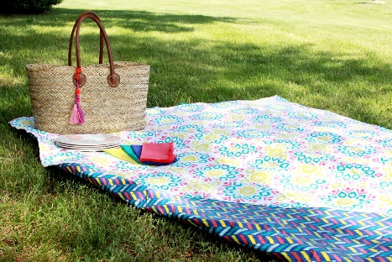
Challenges for Goldfinch and Chaffinch Children:
You can do these challenges in any order. You may choose to do all of them or just a couple. The choice is yours but each one will help you to learn something new. After you’ve completed them, reflect on how you used the 5R’s or the school values to help you learn. Which was your favourite activity and why?
- Watch these short clips on healthy eating before planning your picnic
https://www.bbc.co.uk/bitesize/topics/zrffr82/articles/zppvv4j
https://www.bbc.co.uk/bitesize/topics/z4d82hv/resources/1
Use the picnic planning document to help you organise your ideas.

- With an adult, go to this American Design a Sandwich site: https://www.barneybrown.com/createsandwich/
You can add your choice of bread, filling and topping etc. when ordering your prefect sandwich – just don’t hit BUY! It’s an interesting way to feed your creativity but it is also good for your maths brains.
- Using simple addition and subtraction skills can you calculate how much each item costs?
- Can you use your multiplication skills to ‘scale up’ your choice for everyone on your picnic eg $8.50 x 4.

- You could also think about opening your own sandwich shop.
- What would you call your shop?
- Logo? Advertising jingle?
- How much would you charge for each item?
- Would you use plastic wrappers? Or something more sustainable?
- What would your unique offering be? How would you hook in your customers? Loyalty scheme?
- Would it be take away or eat in? Table design? Crockery?

- Can you design a poster of healthy diet choices?
- Make a collage of your favourite healthy foods – use old magazines or draw items or both.
- Can you make a map of where you would like to go for a picnic? It can be a real location or fantasy - design a key to show the important features on your map.
- Can you find a healthy food from each continent? Challenge – take one continent then find a healthy food from each country on that continent. Which is your favourite and why?
- Write invitations to your picnic. Why should people come?
- If you do have a picnic, in your garden or elsewhere, can you take a photo or draw a pictutre of it then write a short recount as a memory of the event? Use all the writing skills you’ve covered in lockdown to help you.
- Design some games to play on your picnic…eye spy or sports or memory games…what’s your favourite?

