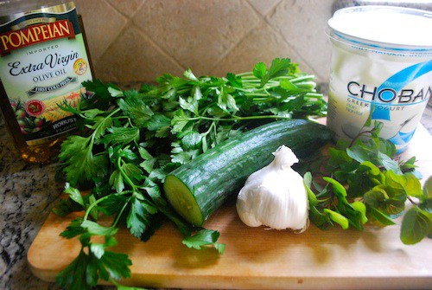

Egyptian Snacks: Salatit Zabadi
- 2 1/2 cups of Greek-style plain yogurt
- 1 smaller English cucumbers, deseeded
- _{salt}
- _{1 clove of minced garlic}
- a handful of mint leaves, chopped
- _{drop of olive oil}

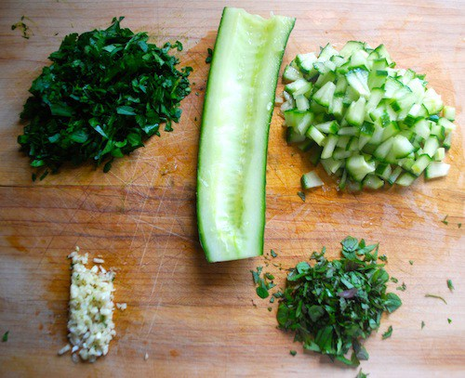

First slice the cucumbers into very thin slices, and then dice them. Place them into a shallow bowl and sprinkle with salt.
After an hour, you will see that the salt will have drawn out the liquid. Drain it, and combine the cucumbers, yogurt, garlic, mint, and finally the olive oil. On a hot day, this is cool and refreshing with pita breads, or over kebabs.

Egyptian Flatbread (Aish Baladi)
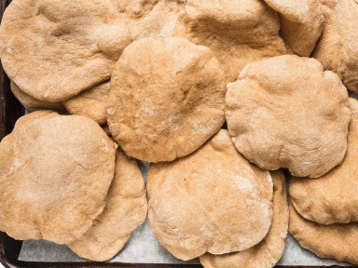
Egyptian Flatbread (Aish Baladi)
Similar to pita, but made with whole wheat flour, this Egyptian flatbread is traditionally baked in scorching-hot ovens in Cairo's bustling markets. Home cooks can achieve similar results with a baking stone and an oven cranked to high.
_{Ingredients}
- 2 cups all-purpose flour, plus more for work surface
- _{1 teaspoon salt}
- _{3/4 cup milk}
- _{1 tablespoon olive oil}
- Preheat oven to 375 degrees F (190 degrees C). Line a baking sheet with parchment paper.
- Whisk flour and salt together in a bowl; form a well in the centre. Add milk and oil; mix until smooth dough forms.
- Turn dough out onto a lightly-floured work surface; knead until smooth and pliable, 10 to 15 minutes. Set dough aside to rest for 15 minutes.
- Divide dough into 4 equal pieces; roll out each piece with a rolling pin to 1/4-inch thickness. Arrange on prepared baking sheet.
- Bake in the preheated oven until lightly browned, 8 to 10 minutes.

