Optional Chaffinch Home Learning Grid – Autumn Term 2 2024 – What did the Romans do for us?
You can select from any of the ideas or be completely creative with what you do – as long as it links to the Romans. Enjoy working on one piece of homework per week if you can. You can choose whatever you’d like to do but try and do a mix of activities to showcase at our Roman Family Learning Event on Thursday 5th December (more details to follow). Please bring in your home learning on Mondays. Spelling, Reading and Times Table Mountain homework will continue.
Draw | Write | Create
Research Roman Coins.  Draw some coins neatly.  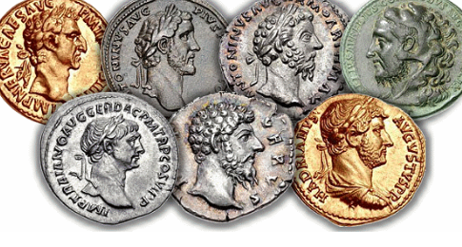 | Make up a crossword using  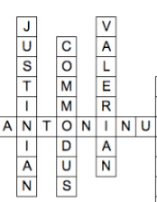  interesting Roman words  eg toga, tunic, villa . write the clues for people to solve. | Choose a  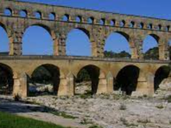  Roman  invention.  Draw a  labelled  diagram to  show how it  works.
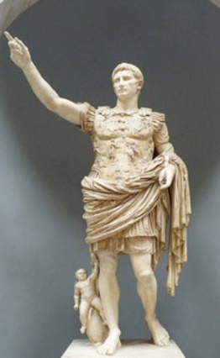  Draw a picture of  a famous Roman and  write some facts  about them  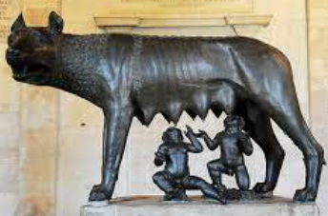 | Write down a word  related to the  Romans for each  letter of the  alphabet. Then write  a sentence about  each one to explain  it! | Choose the one  thing that interests    you the most about  the Romans and  create a song/poem  or rap to explain it.  Record/write down  your composition or  perform it at school.
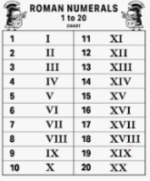  Write out the  number bonds  to 20 using  Roman  numerals. | Write an acrostic poem for the  word ROMANS. | Find a Roman recipe. Create  this recipe and take a photo  of your creation (Write the  recipe to go with your photo in  case others would like to have  a go).

