Chaffinch Reading Challenge
Spring 2025
Can you rise to our challenge?  We would love you to take part in our Spring Reading Challenge and tick off each activity when completed. Get your grown up to sign your sheet anywhere to say you have completed the challenge. We would love to see photographs of you enjoying this challenge as you complete a fun task. Please email to Finchparents@finchampstead.wokingham.sch.uk and we will be able to share on our class page. Return your paperwork to a Chaffinch Teacher by 31st March 2025 and we will enter you into the prize draw. Good Luck Chaffinches! | 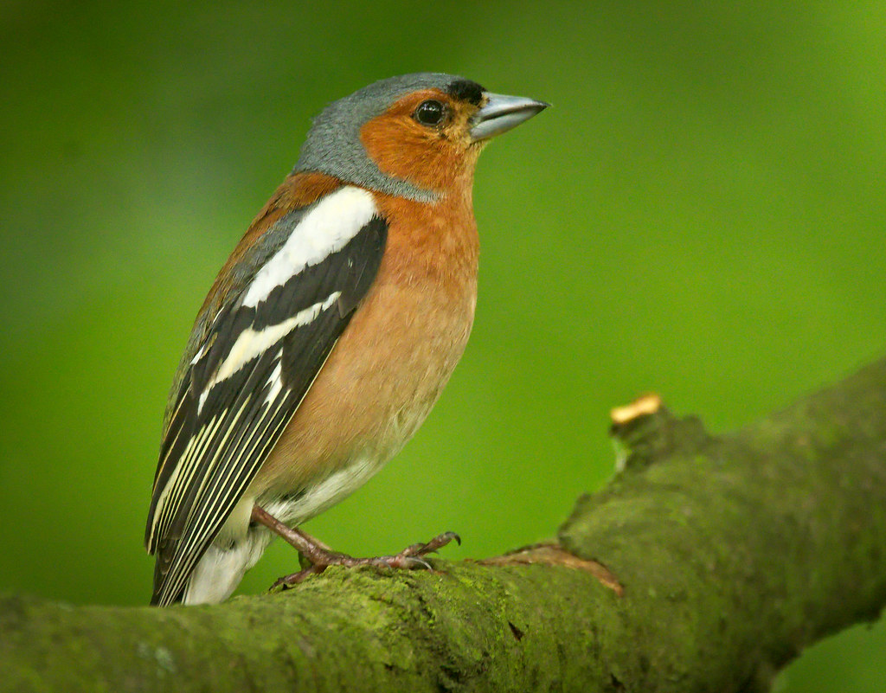
You can complete these tasks in any order. Tick each task as you do it. You might be able to tick two at once
Read a non-fiction book | Read a book standing up | Read a book set in the past | Read a joke book | Read a news article (kids newsround etc) | Give a book to someone (used or new* )
Read a book recommended by a friend | Read a book set in another country | Read in a den with a torch | Go to the library | Read a picture book aloud | Listen to an audio book
Read a book recommended by an adult | Read some poetry | Read in an unusual place (you choose) | Read under a blanket | Read about a sports event | Listen to your teacher read
Tell your teacher about a book you’ve enjoyed | Read aloud to someone | Watch a video of a book being read | Read a recipe | Read in bed | Read to your pet or teddy or pretend!
We have lots of books in the book exchange at the front of school.
Choose one to give away to a friend or loved one.

