Year 5 answers Friday 27th | Year 6 answers Friday 27th
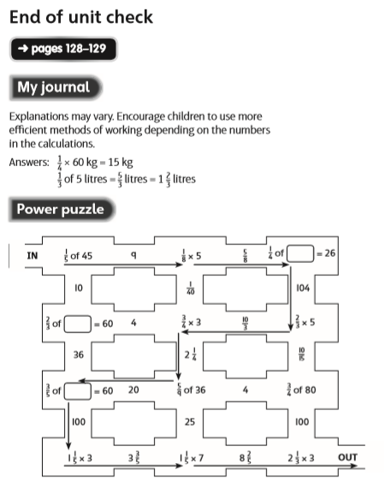 | 

