Year 5 answers Thursday 26th | Year 6 answers Thursday 26th
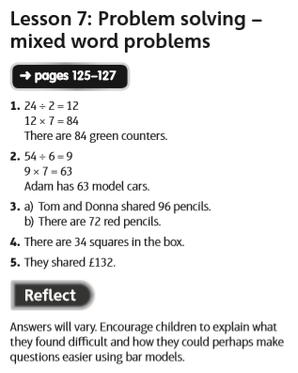 | 

