Goldfinch English – Home Learning tasks - Week Beginning 23 March 2020
Monday | Look at the attachments for Monday’s English – semi colons  Complete in your exercise books.
Tuesday  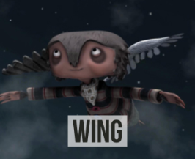 | Watch the film ‘Wing’ on Literacy Shed  https://www.literacyshed.com/the-thinking-shed.html  I am learning to develop a character using expanded noun phrases and relative clauses.  “He has one wing.” Can you improve this sentence by expanding the noun phrase and adding in detail through adverbial/preposition phrases. E.g. “Sprouting from his right shoulder, he has a feathery, white wing.” Think how this has improved the description then try again with another sentence. Can you write a sentence that includes an expanded noun phrase and a relative clause?  In your exercise books, write at least two paragraphs describing the physical appearance of Wing. You may use a thesaurus to select appropriate descriptive vocabulary and must include expanded noun phrases alongside a variety of sentence types and clauses. As an extension, think about the Crows and write a paragraph to describe them.
Wednesday | I am learning to start sentences in different ways to make writing more interesting.  Look at the extract in ‘Wednesday’s Writing Example’ at the end of this table.. Think why the piece is a poor example. How could you use DADWAVERS to improve it by starting sentences in different ways? Have a go at editing and redrafting the sentences with improved openers.  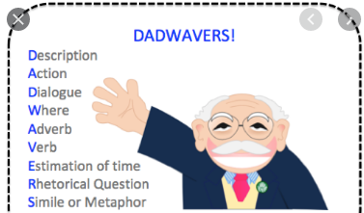
Thursday | I am learning to write from a character perspective.  Write a diary entry from the perspective of one of the crows which explains their dislike for  Wing. You must use DADWAVERS and include diary features (Opening, date, informal language, tense, first person, pronouns, describes events in chronological order, reflection, thoughts and feelings, emotive language).
Friday | I am learning to integrate dialogue into my writing  “Thank you so much,” the boy whispered gratefully. How is punctuation used? When should a comma be used?  The grateful boy whispered his thanks to the girl. What is the difference in the sentences? Can you identify direct/ indirect speech? Does use of punctuation differ between them?  Who are the characters and at what points might they talk to one another? Focus on the extract 0:30-0:47. What is happening? If the characters spoke, what might they say to each other?  Write a narrative using events from 3:08- 3:36 of the clip. Who is the girl? What would she and Wing say to one another? Write a narrative with a combination of dialogue, reported speech, action and description for this scene.

Wednesday’s Writing Example
How could you use DADWAVERS to improve this text by starting sentences in different ways?



