Year 5 answers Friday 3rd April | Year 6 answers Friday 3rd April
Unit 11 Lesson 5  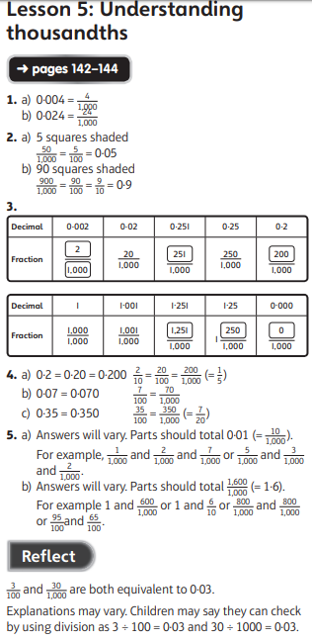 | Unit 12 Lesson 2  

