Year 5 answers Thursday 2nd April | Year 6 answers Thursday 2nd April
Unit 11 Lesson 4  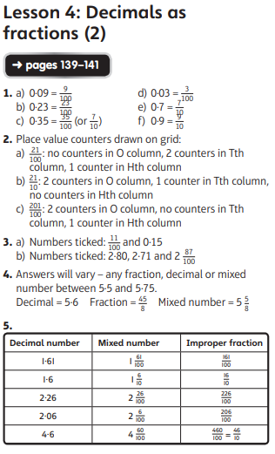  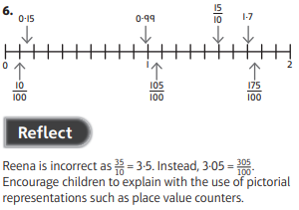 | Unit 12 Lesson 1  

