Year 5 answers Wednesday 1st April | Year 6 answers Wednesday 1st April
Unit 11 Lesson 3  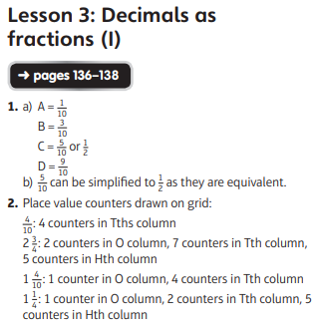  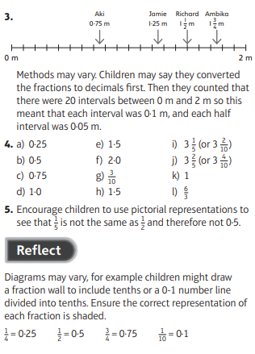 | Unit 11 Unit Check  

