Year 5 answers Tuesday 31st | Year 6 answers Tuesday 31st
Unit 11 Lesson 2  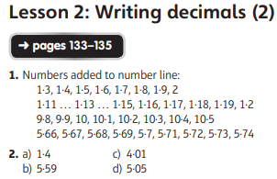  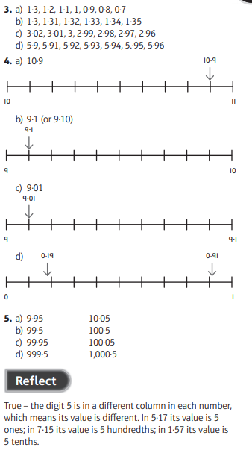 | Unit 11 Lesson 11  

