Y6 Maths Revision Tasks Due: Thursday 26th March 2020
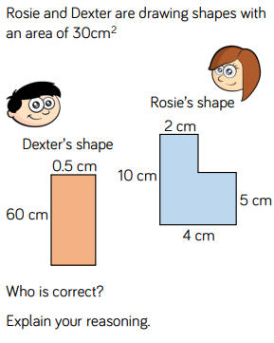 | Rosie’s area=  5x4=20cm² + 5x2=10cm² = 30cm²  Dexter’s area = 60 x 0.5 = 30cm²  So they are both correct
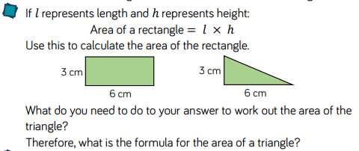
Half the area of the rectangle to find the area of the right angles triangle:
(3 x 6)÷2 = 9cm²

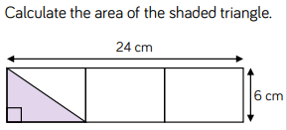

Find the area of one of the smaller rectangle : (24x6)÷3=48cm² or (24÷3)x6=48cm²
Then half it to find the area of the triangle: 48cm² ÷2=24cm²

Y5 Maths Home Revision Due: Thursday 26th March 2020
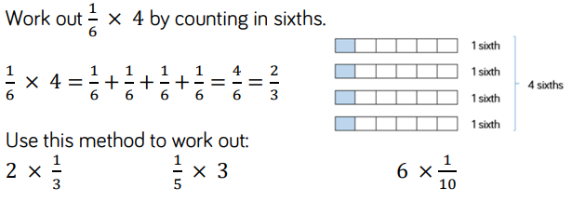
2/3 3/5 6/10

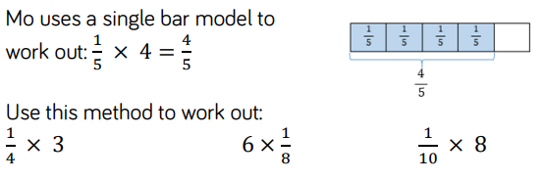

¾ 6/8 8/10

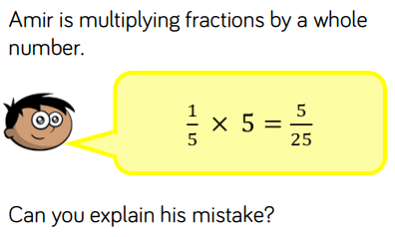

He has multiplied the numerator and the denominator. The answer should be 5/5 or 1

