Goldfinch English – Home Learning tasks - Week Beginning 30 March 2020
Monday   |   Complete this Purple Mash activity to revise brackets, dashes and commas for parenthesis then try this task on Education City:  
Tuesday  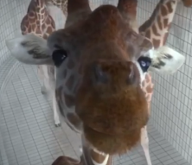  I really hope you enjoy using this film. | I am learning to organise and illustrate a process into clear, sequenced stages.  https://www.literacyshed.com/divinggiraffes.html or  https://www.bing.com/videos/search?q=diving+giraffes+youtube+literacy+shed&docid=608046010106448983&mid=49636831EF045DD1A4A849636831EF045DD1A4A8&view=detail&FORM=VIRE  Watch the film. From 1:30 onwards, watch the giraffes carefully and remember the actions and technique you see in the correct order. You may wish to pause and think about different frames (there is a good slow-motion tuck and roll at around 4mins). After you have finished watching the film, think about the giraffes’ high diving technique.  Break down the giraffe diving process into stages. You can illustrate with annotated diagrams to show this, step by step, and describe what is happening in each image.  Use Tuesday English Resource below
Wednesday | I can write instructions/explanations.  https://www.literacyshed.com/divinggiraffes.html or  https://www.bing.com/videos/search?q=diving+giraffes+youtube+literacy+shed&docid=608046010106448983&mid=49636831EF045DD1A4A849636831EF045DD1A4A8&view=detail&FORM=VIRE  Using your imagination and ideas from the film, write a user guide explaining how you would train giraffes to high dive. How should you get the giraffes started, what techniques should the giraffes use etc. Think about the features you have identified in explanations and instructions. Yesterdays notes and diagrams should help you. Try to use time conjunctions (fronted adverbials) to sequence what you say – don’t worry about using technical vocabulary for diving just yet. A good example: First, carefully lower the first giraffe into place using the hanging apparatus: he will be responsible for launching the diver into the air. Next, the other giraffes must get into position etc …  Use Wednesday English Resource below
Thursday | I can write in the style of a newspaper report.  https://www.literacyshed.com/divinggiraffes.html or  https://www.bing.com/videos/search?q=diving+giraffes+youtube+literacy+shed&docid=608046010106448983&mid=49636831EF045DD1A4A849636831EF045DD1A4A8&view=detail&FORM=VIRE  Imagine that you are a newspaper reporter. You have been asked to cover the story of the diving giraffes. What questions would you want to answer as a reporter? How would you write in the style of a newspaper report? Can you create a clever headline using puns or alliteration? How would you include reported speech and direct speech?  Use Thursday English Resource on class page
Friday | Reading Comprehension – Five Children and It  Use attachment Friday English Resource on class page

Tuesday English Resource - Goldfinch
Key notes – How to train a Giraffe to High Dive – Key Steps
Annotated diagram | Training notes
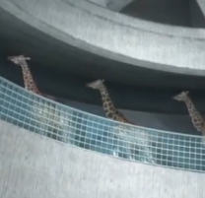
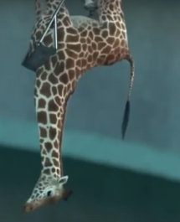
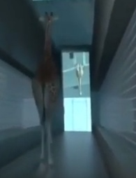
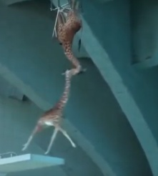
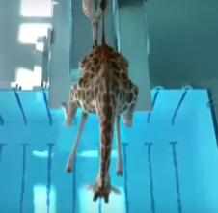
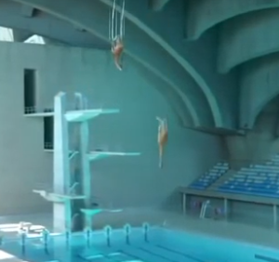
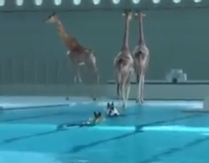
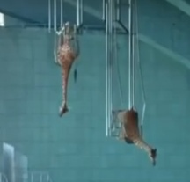
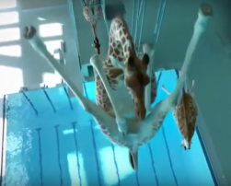

Wednesday English Resource - Goldfinch


______________________________________________________________________________________________________________________________________________________________________________________________________________________________________________________________________________________________________________________________________________________________________________________________________
______________________________________________________________________________________________________________________________________________________________________________________________________________________________________________________________________________________________________________________________________________________________________________________________________
______________________________________________________________________________________________________________________________________________________________________________________________________________________________________________________________________________________________________________________________________________________________________________________________________
______________________________________________________________________________________________________________________________________________________________________________________________________________________________________________________________________________________________________________________________________________________________________________________________________
___________________________________________________________________________________________________________________________________________________________________________________________________________________________________________________________________
______________________________________________________________________________________________________________________________________________________________________________________________________________________________________________________________________________________________________________________________________________________________________________________________________
______________________________________________________________________________________________________________________________________________________________________________________________________________________________________________________________________________________________________________________________________________________________________________________________________
______________________________________________________________________________________________________________________________________________________________________________________________________________________________________________________________________________________________________________________________________________________________________________________________________
______________________________________________________________________________________________________________________________________________________________________________________________________________________________________________________________________________________________________________________________________________________________________________________________________
_________________________________________________________________________________________________________________________________________________________________________________________________________________________________________________________________________________________________________________________________________________________________________________________________________________________________________________________________________________________________________________________________________________________________________________________________________

