Goldfinch Easter Holidays Project

Can you make a Book Trailer?
Watch this Book Trailer for ‘Journey to River Sea.’ https://www.youtube.com/watch?v=16aBxcCw_h4
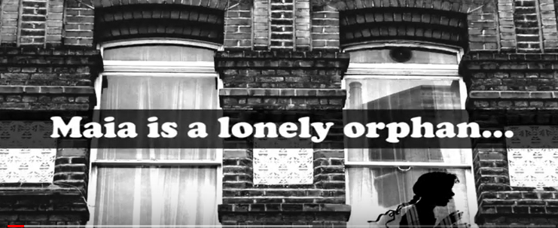
Using this trailer as a model, can you create a book trailer for a book that you’ve enjoyed?
You can use any media you like e.g. Scratch, iMovie, Movie Maker or even Powerpoint to make the trailer.
Can you include:
- Text
- Music
- Images
- Or even moving images?
If you manage to upload it, share the link with Mrs Wirth via the finchparents email or save it to bring into school when we return.

