Goldfinch
Summer Term 2020
Design and Technology Project
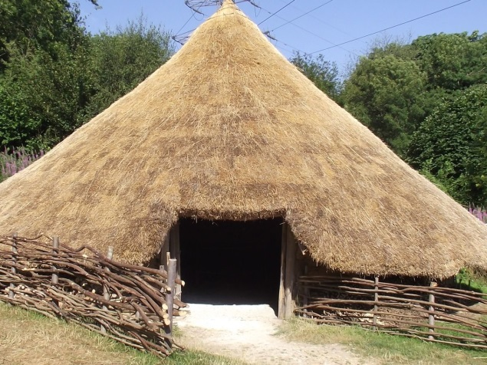 | 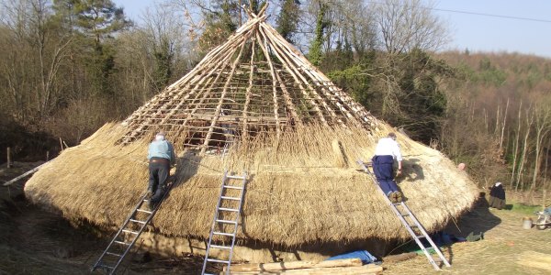
Design and Make an
Iron Age Round House
Name:
Paste a photo of
your finished construction here.

You are an Iron Age villager. You have only natural resources with which to build your home.

Your mission is to build a shelter for two ‘Iron Age’ Lego figures!
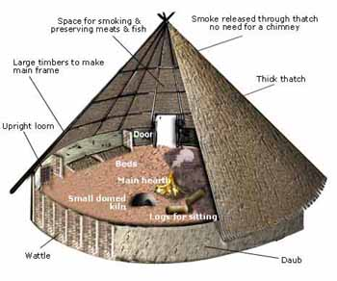

To be successful, your shelter must:
- Be able to withstand a 1kg weight being placed on the roof. The two figures must remain protected;
- Keep the figures dry. This will be judged by placing the figures on tissue paper. The tissue must remain dry when 200ml of water is poured over the top of the shelter;
- The shelter and figures must be able to withstand a 30 second blast from an electric fan or hairdryer.

Monday: What was accommodation like for the people in the Iron Age? ( Investigate products/images to collect ideas )
Do some research on the internet and then make annotated sketches to show how their structures were built, labelling them to show the materials and methods that were used.

Iron Age Round Houses – Fact file
Do some research on the internet and then list the 8 most interesting facts (in order of interest) that you learnt about Iron Age Round Houses

1

2

3

4

5

6

7

8

Tuesday: Make a detailed plan of a model of an Iron Age shelter that you would like to build.
AF: sketch and model alternative ideas. / Develop one idea in depth / record ideas using annotated diagrams
You need to include notes about:
- Materials you intend to use
- Methods for joining and sticking
- Measurements
- Finishing touches – decoration

Front View

Plan View

Wednesday: Instructions - Produce a Step by Step Plan to show how to make your shelter. (Plan the sequence of work / design plans which can be used by someone else / use correct technical vocabulary)
Include information on:
- What equipment you will use, how and why.
- How you will join the different pieces
- The amount of time you think each part will take to complete
- Remember to include all the success criteria for writing instructions
_____________________________________________________________________________________________________________________________________________________________________________________________________________________________________________________________________________________________________________________________________
_____________________________________________________________________________________________________________________________________________________________________________________________________________________________________________________________________________________________________________________________________
_____________________________________________________________________________________________________________________________________________________________________________________________________________________________________________________________________________________________________________________________________
_____________________________________________________________________________________________________________________________________________________________________________________________________________________________________________________________________________________________________________________________________
_____________________________________________________________________________________________________________________________________________________________________________________________________________________________________________________________________________________________________________________________________
__________________________________________________________________________________________________________________________________________________________________________________________________________________________________________________________________________________________________________________________________________________________________________________________________________________________________________________________________________________________________________________________________________________________________________________________________________________________________________________________________________________________________________________________________________________________________________________________________________________________________________________________________________________________________________________________________________________________________________________________________________________________________________________________________________________________________________________________________________________________________________________________________________________________________________________________________________________
___________________________________________________________________________________________________________________________________________________________________________________________________________________________________________________________________________________________________________________________________________________________________________________________________________________________________________________________________________________________________________________________________________________________________________________________________________________________________________________________________________________________________________________________________________________________________________________________________________________________________________________________________________________________________________________________________________________________________________________________________________________________________________________________________________________________________________________________________________________________________________________________________________________________________________________________________________________
Thursday - Shelter Evaluation
Justify your decisions about materials and tools used
List the materials you used and state whether they were a good or bad choice.
Materials Used | Good/bad choice and why?

What equipment /tools did you use? How did they help you with your work?
Tools/Equipment used | How useful? Problems?

Did you have any problems when making your shelter? How did you solve these problems?
What worked well? | What did not work well?

How well did your structure meet the design criteria?

How could your design be improved?

Which part of the project did you enjoy the most and why?
Friday: Imagine that you want to sell your Iron Age Round House on Rightmove.

Write an estate agents ‘blurb’ using persuasive language to make all aspects of your dwelling sound attractive to potential buyers.
Which features would you wish to highlight to your potential buyer?
When we come back to school:
Look at shelters designed and made by other people.

Choose 2 designs from the classroom display.
- Describe the materials used.
- Write down one good things about the shelter
- Write down one suggestion for improvement

First Shelter:

Second Shelter:

