Goldfinch English – Home Learning tasks - Week Beginning 4th May 2020
Don’t forget to scroll down to find the resources for the week.
Monday  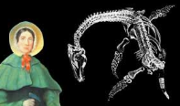 | Can I collect and analyse information for a biographical recount ?  Make notes from a film clip about Mary Anning and then combine these with identified key facts from the second website. You may do further research if you wish.  https://www.bbc.co.uk/teach/class-clips-video/true-stories-mary-anning/zn7gd6f  https://www.bbc.co.uk/bitesize/topics/zd8fv9q/articles/zf6vb82
Tuesday | Can I plan to write a biography?  Reread the WAGOLL. How would you ‘box up’ the key facts for planning purposes? Then think about how you would ‘box up’ your research notes to organise your biography.
Wednesday | Can I write a biography?  Use your planning notes and the key features of a biography checklist to write an interesting biography about the fossil collector, Mary Anning. Remember how you imitated the style of the WAGOLL last week although try to write this piece independently. Try to avoid cutting and pasting from the internet.  If you write this on word you could email your work. If you hand write it, take a photo and email that.
Thursday  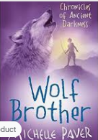 | Reading Comprehension – Wolf Brother by Michelle Paver  Make sure you have listened to all the chapters from last week before you start today’s lesson.  https://wke.lt/w/s/kKHTv0  This week’s art also links to today’s lesson.
Friday | Bank Holiday  You may wish to use this time to complete your biography if you didn’t manage to do so on Wednesday.
Monday 4th May 2020
Can I collect and analyse information for a biographical recount?
As part of our topic, Digging into the Past, we will be investigating the life of Mary Anning, an English palaeontologist, famous for her ‘curios’ found on the beach in her hometown in Dorset. Indicate ‘facts’ in red and opinions in ‘blue’ Some key years have been added but you need to complete her life timeline with your own research.  Mary Anning Timeline | 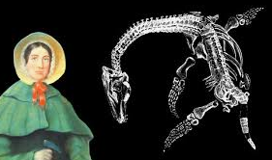
21 May 1799 - Born

1810

1811

1826

9 March 1847 - Died
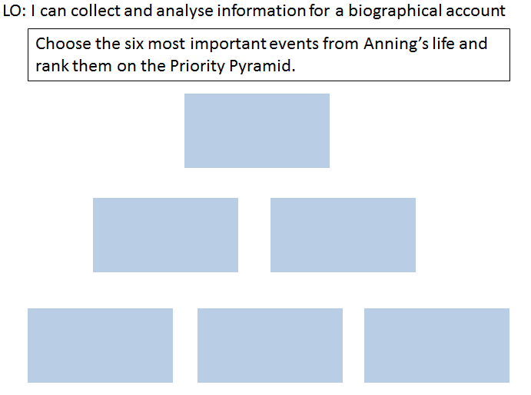
Explain why you choose the top piece of information as the most important?
______________________________________________________________________________________________________________________________________________________________________________________________________________________________________________________
Tuesday 5th May 2020
Re-read this model text to remind yourself of the structure of a biography.
Charles Darwin – A Biography (WAGOLL)  There was one man who caused major controversy in his time and changed the way the world understood evolution – Charles Darwin. Now, surely you’ve heard of this famous scientist? | 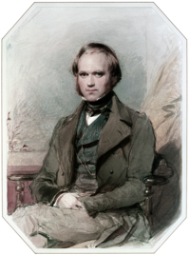
Perhaps he’s been mentioned during one of your science lessons but didn’t seem hugely important at the time? Well, in fact, he was an incredibly important person, whose discoveries kick-started the theory of evolution by natural selection and would change the world; they are still hugely important in the modern world!
Early life and childhood
Darwin’s childhood and strict parents probably created the intellectual man that he became. Born on the 12th February 1809, Darwin grew up in a privileged and well-connected family. They were known for their authoritarian attitudes; their high expectations extended to Darwin and all of his siblings. His family home was located in Shrewsbury, Shropshire, where his love for nature would be ignited. His younger years were filled with exploratory walks, where he hunted for insects, plants and minerals to study in more detail and developed his interest even further. Being nearly the youngest sibling in his family – he was fifth out of six children – he attended the Shrewsbury School for boys.
At the age of thirteen, Charles demonstrated his early passion for science: he built a science laboratory in his garden shed. Initially, this pleased his father – a doctor – and Darwin was soon enrolled in a school in Edinburgh to pursue a medical career. However, a distinct disliking for blood halted any further advancement in this profession; he was not going to follow in his father’s, grandfather’s or brother’s footsteps. Instead, his father enrolled him at Cambridge, where he studied to become a vicar – a rather different profession to a doctor, don’t you think? Having successfully passed his studies, he yet again changed course and decided to eventually pursue his dream of becoming a naturalist. Despite support from friends and teachers, his biggest chance was soon to be received: an offer which stood above the rest and would catapult him into the history books forever!
The Beagle
Upon receiving a letter from John Henslow, Darwin was finally given the opportunity he had always dreamt of! The captain of the HMS Beagle (Rover FitzRoy) was searching for a naturalist to accompany him and his crew to various locations dotted around the globe, to explore, record data and retrieve new information; Darwin jumped at the opportunity!
The HMS Beagle embarked in 1831, carrying Charles along with it. Unfortunately, Darwin suffered badly from nausea; yet this did not deter him. The trip was an extremely challenging experience anyway: with seventy-five crew members on board, conditions were poor and very cramped. However, this did not dampen Darwin’s spirits. By 1835, after five years of voyaging, they had reached the Galapagos Islands (which lie to the west of Columbia in the Pacific Ocean).
Darwin was amazed by what he saw: Galapagos tortoises, which, rumour states, he attempted to ride; komodo dragons, a potentially dangerous creature due to the fact they can eat up to eighty percent of their body weight in one sitting; and a variety of finches, which would lead to Darwin making his now-famous theories surrounding evolution and natural selection. Who would have thought that some small, relatively insignificant birds would go on to inspire one of the most famous naturalists of all time and change the way people viewed evolution! It’s simply impossible to imagine!
The Galapagos Islands
Despite having travelled the globe, it was the Galapagos Islands which were to be the location of his most famous theory. The Galapagos Islands are made up of several islands, created due to volcanic eruptions. It was here that Darwin came to the realisation that each island held its own specific variety of finch: they had adapted to the specific environment of each island. It was his belief that the types of finch that (in this case) did not have the appropriate shaped beak for the food source of the island would die off; the ones who had a suitable beak shape would thus be able to feed, then reproduce and consequently bear offspring, which would have the most suitable size beaks. Closer studies supported his theories and he was able to establish that those birds with long, thin beaks were able to eat insects; whilst birds with shorter, stronger beaks were able to break nuts and seeds. The humble finch had given him the evidence he needed; now he just needed to convince everyone else of his seemingly ‘crazy’ idea! Little was he to know the shockwaves and controversy that he would cause across the world!
The Origin of Species
Inspired by his findings, Darwin recorded his ideas, along with detailed diagrams to support his theories. These were then sent to England to other naturalists working in similar areas. He authored a book named ‘The Origin of Species’, which explained his notion of natural selection and survival of the fittest: a theory which suggested that creatures who had a greater advantage in their environment – such as the finches and their beak shape – had more chance of reproducing, who would go on and reproduce themselves. However, this idea was extremely contentious: it went against many religious beliefs, which were particularly prevalent at this time. It might be hard to imagine in this modern world where science dominates, but at this time, it was strongly believed that God had created everything. In fact, Darwin was so fearful of the reception his book would receive, he delayed publishing it for almost twenty years; he stated that ‘explaining his ideas was like confessing to a murder!’ Eventually the now-famous book was published in 1859 and is still – more than one-hundred-and-fifty years later – referred to. His book really did revolutionise the world we live in! Just imagine, if he had been a doctor or a vicar, things would be very different in our modern world!
Tuesday 5th May Can I plan to write a biography?
Use your time line to make notes and plan your biography of Mary Anning. Remember the features of a biography from last week’s lessons. How will you organise the paragraphs?
Introduction
Early life and childhood

Family Business
Work with scientists
Major
discoveries
Legacy - how and why is she remembered?
Wednesday 6th May
Can I identify the main features of a biographical text?
Use this checklist to make sure that you have included the appropriate features of a biography.
Have you used:
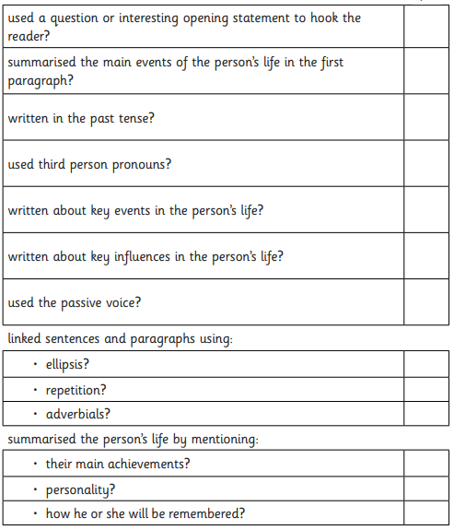
What punctuation will you include and for what purpose will it have been used?

Mary Anning – Fossil Hunter

________________________________________________________________________________________________________________________________________________________________________________________________________________________________________________________________________________________________________________________________________
________________________________________________________________________________________________________________________________________________________________________________________________________________________________________________________________________________________________________________________________________
________________________________________________________________________________________________________________________________________________________________________________________________________________________________________________________________________________________________________________________________________
________________________________________________________________________________________________________________________________________________________________________________________________________________________________________________________________________________________________________________________________________
________________________________________________________________________________________________________________________________________________________________________________________________________________________________________________________________________________________________________________________________________
________________________________________________________________________________________________________________________________________________________________________________________________________________________________________________________________________________________________________________________________________
________________________________________________________________________________________________________________________________________________________________________________________________________________________________________________________________________________________________________________________________________
______________________________________________________________________________________________________________________________________________________________________________________________________________________________________________________

