Goldfinch English – Home Learning tasks - Week Beginning 11th May 2020
Don’t forget to scroll down to find the resources for this 2 week unit.
Monday  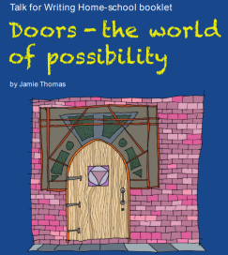 | Doors -The World of Possibility  Activity 1 & 2 ( below)  Email activity 2 for the website and comments
Tuesday | Doors -The World of Possibility  Activity 3 & 4 ( below)  Email Activity 3 for the website and comments
Wednesday | Doors -The World of Possibility  Activity 5 ( below)
Thursday | Doors -The World of Possibility  Activity 6 ( below)  Email your ‘Pattern of Three’ sentences for the website and comments
Friday  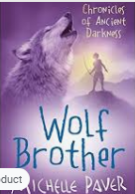 | Reading Comprehension – Wolf Brother by Michelle Paver  Make sure you have listened to all the chapters from last week before you start today’s lesson.  Download this weeks Reading Journal on the link.  https://wakelet.com/wake/h8AzXLIXmoUI1z9h0VzCi

Monday 11th May 2020
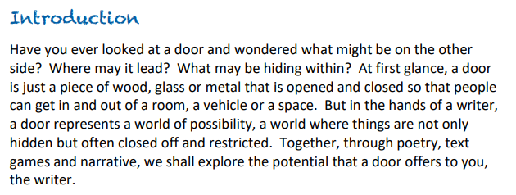
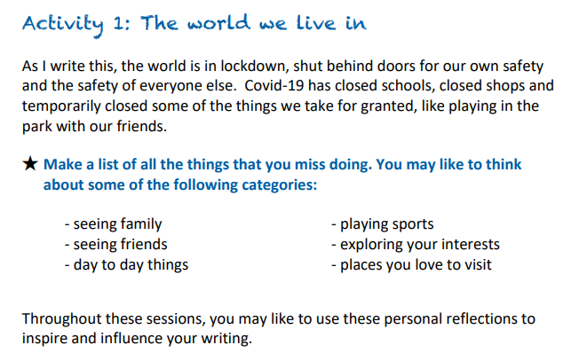
My List:
____________________________________________________________________________________________________________________________________________________________________________________________________________________________________________________________________________________________________________________________________________________________________________
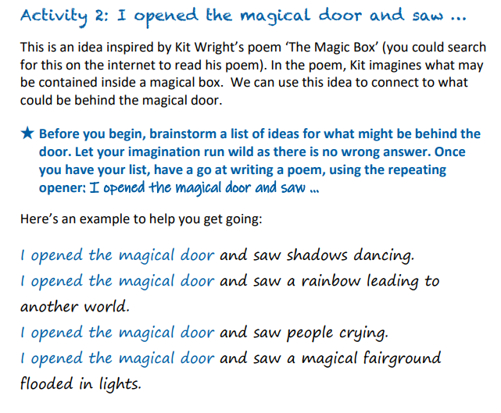
I opened the magical door…
I opened the magical door…
I opened the magical door…
I opened the magical door…
I opened the magical door…
I opened the magical door…
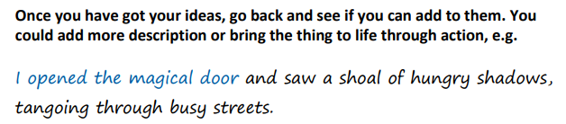
Have fun adding to your ideas and let your imagination run wild. Have a read of the poem on the next page - created by Y6 children - to help you get ideas.
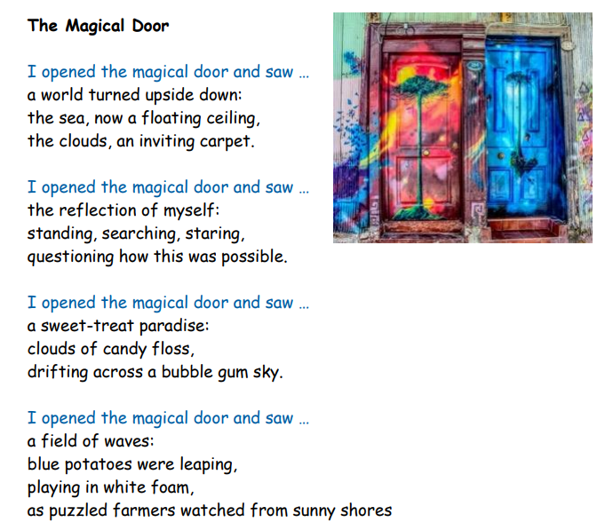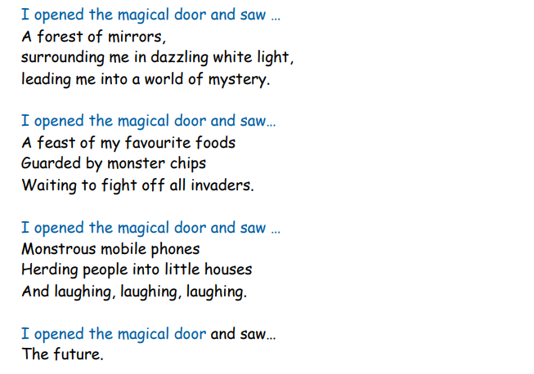
Now it’s your turn. When you’ve finished, email this page for comments.
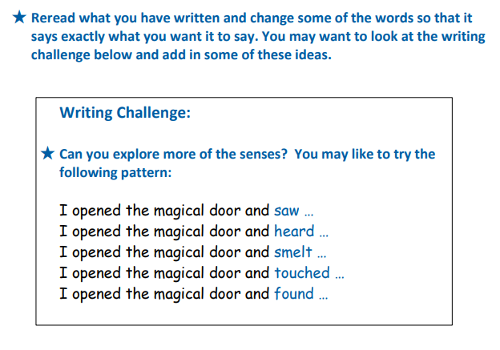
I opened the magical door and … ____________________________________________________________________________________________________________________________________________________________
I opened the magical door and … ____________________________________________________________________________________________________________________________________________________________
I opened the magical door and … ____________________________________________________________________________________________________________________________________________________________
I opened the magical door and … ____________________________________________________________________________________________________________________________________________________________
Tuesday 12th May
Activity 3: Artistic challenge
Doors are not only exciting for what may lie behind them, they can be designed to invite you into their world. A few years ago, a derelict area of Funchal in Madeira was transformed by local artists who decided to bring the dead doors to life. The beauty of the art opened new doors, and soon homes, shops and restaurants flourished there. Here are a few of those doors.
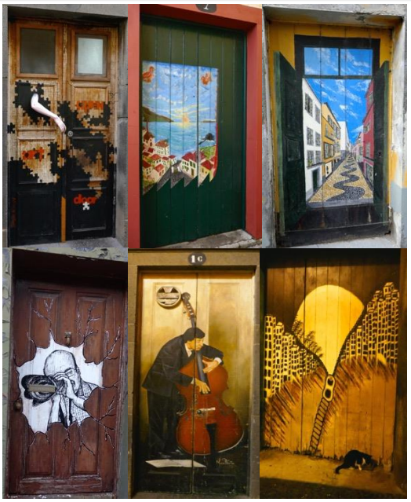

Have a go at drawing, painting or creating your own door.
What design would you choose? What would it represent?

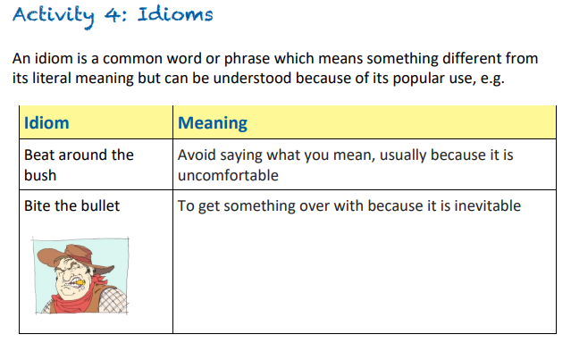
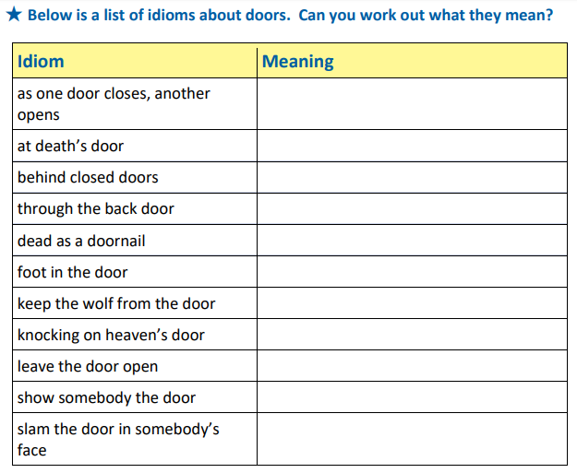
Wednesday 13th May
Activity 5 - The Door  In this session, we are going to consider the importance of fluency and expression when we read.  Begin by reading Miroslav Holub’s poem The Door.  You may like to listen to these two contrasting performances:  https://www.youtube.com/watch?v=bazJvnuOLMM  https://www.bbc.co.uk/programmes/p011kx3r  ★ Decide which reading you prefer and explain why.  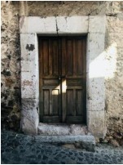 | 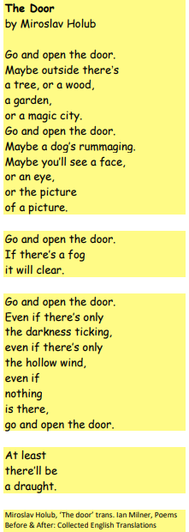
Now make some notes on the poem:
- What did you like about the poem?
- What was your favourite line and why?
- How did the poem make you feel?
- Which line in the poem did you find the most interesting and why?
- Are there any parts of the poem that leave you with unanswered questions?
- What questions would you like to ask the poet, Miroslav Holub?

★ Decide how you would perform this out loud and have a go at performing at home.
Thursday 14th May
Activity 6: Read this extract from The Snow-Walker's Son by Catherine
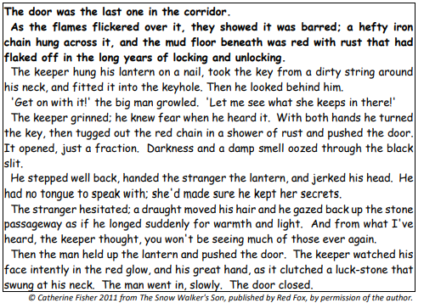
Discuss these questions.
1. The door was the last one in the corridor. What is the significance of the word last? Can you think of another context where the word last has a significant meaning?
2. How do the opening lines (in bold above) set the mood of the story? What are your immediate impressions?
3. Having spent a great deal of time reflecting on the significance of doors and their appearance, what does this description suggest to you?
4. Why has the author described the iron chain as being ‘hefty’? What could the significance of this word be in the context of the story?
5. Darkness and a damp smell oozed through the black slit. How does this make you feel as a reader? What is the relevance of both darkness and a damp smell? Do either of these surprise you; if so, why?

