Goldfinch English – Home Learning tasks - Week Beginning 18th May 2020
Don’t forget to scroll down to find the resources for this 2 week unit.
Monday  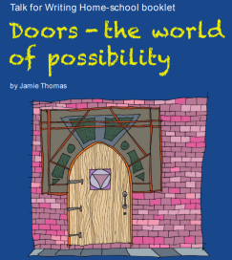 | Doors -The World of Possibility  Activity 7 ( below)  Email the ‘Pattern of Three’ sentences for the website and comments
Tuesday | Doors -The World of Possibility  Activity 8 ( below)  Email your paragraph for Activity 8 for the website and teacher comments.
Wednesday | Doors -The World of Possibility  Activity 9 ( below)
Thursday | Doors -The World of Possibility  Activity 10 ( below)  Email your story to share on the website.
Friday  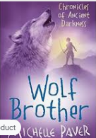 | Reading Comprehension – Wolf Brother by Michelle Paver  Make sure you have listened to all the chapters from last week before you start today’s lesson.  https://wakelet.com/wake/q684kbsPzo-MWXx7-vdxy  Download this week’s Reading Journal on the link and email your task for comments.

Monday 18th May
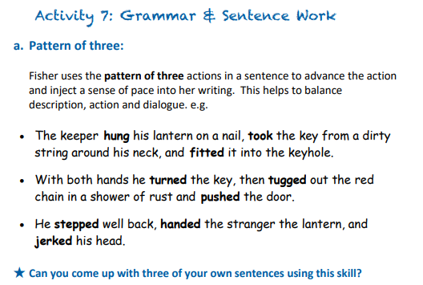
(Remember to use commas to separate items in a list as in the above sentences.)
1

2

3

Semicolon for independent clauses
Check out this link to revise the use of semi colons  https://www.bbc.co.uk/bitesize/topics/zvwwxnb/articles/zshfdxs | 
A semicolon can be used between independent clauses that are closely related in theme. In the following sentences, the writer chooses to use semicolons in both of these sentences rather than using a joining word (conjunction) like because.
• The keeper grinned; he knew fear when he heard it.
• He had no tongue to speak with; she'd made sure he kept her secrets.
★ In your opinion, why has the writer made this choice and what impact does it have on you as the reader?
____________________________________________________________________________________________________________________________________________________________________________________________________________________________________________

★ Can you write two or three sentences of your own that illustrate the power of the semicolon over the use of a conjunction?
1

2

3
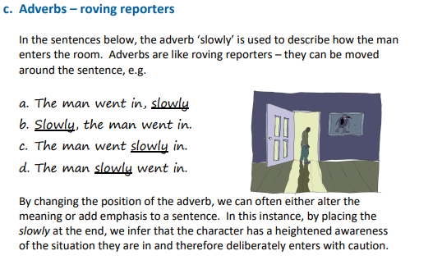
This link will help you revise adverbs: https://www.bbc.co.uk/bitesize/articles/zv73bdm
Try playing around with the adverb position in the following sentences. Consider how it alters the meaning and where the emphasis is best placed.
1. Cautiously, Samantha crept towards the door that stood before her.
2. Sadly, the boy stared out of the window.

★ Now try this out with a sentence of your own.
____________________________________________________________________________________________________________________________________________________________________________________________________________________________________________

Tuesday 19th May
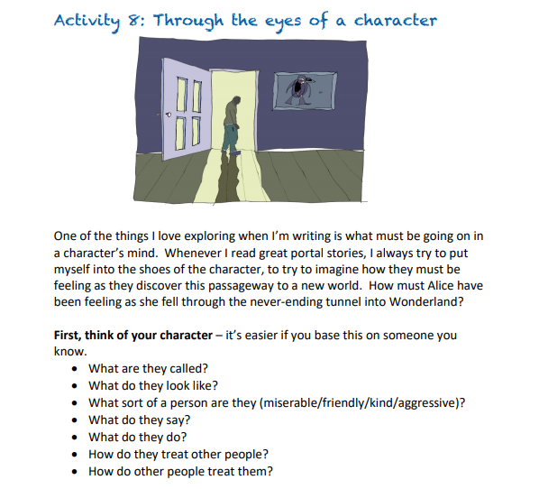
Now compose a short piece of descriptive writing based on seeing a mysterious door through the eyes of your character. To do this, we will use a simple opener to drop the reader straight into the action:  For example:  Samantha stared. … or Ali hesitated. …  We will also try to use some of the tools we explored in The Snow Walker’s Son.  Look at this example:  Samantha stared. There, rising out of the cliff, was an unfamiliar door; its metallic panels were tarnished in rust. Paint flaked off the brittle walls that made up its frame and the door handle rattled in the bitter breeze. Slowly, Samantha gazed all around her, took a deep breath and stepped forward. | 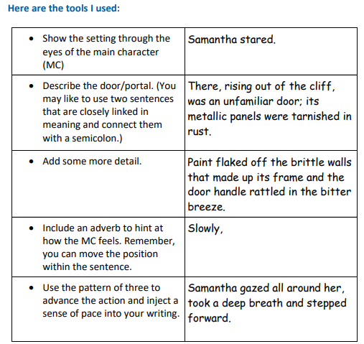
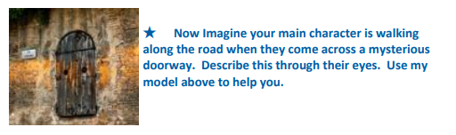
____________________________________________________________________________________________________________________________________________________________________________________________________________________________________________________________________________________________________________________________________________________________________________________________________________________________________________________________________________________________________________________________________________________________________________________________________________________________________________________________________

Email this paragraph for the website and teacher comment.

Wednesday 20th May
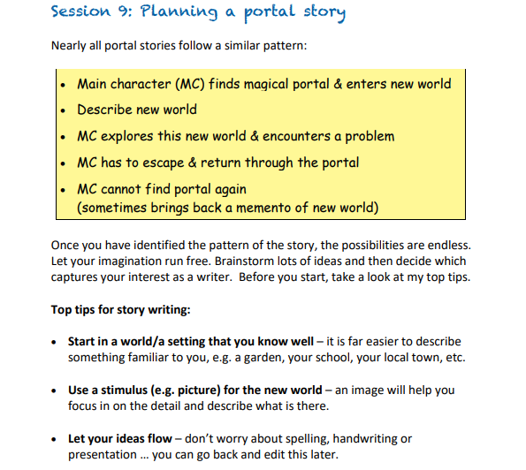
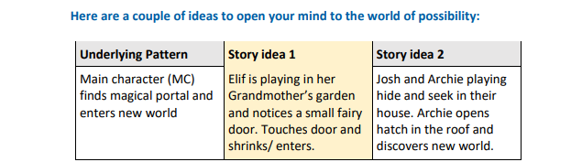
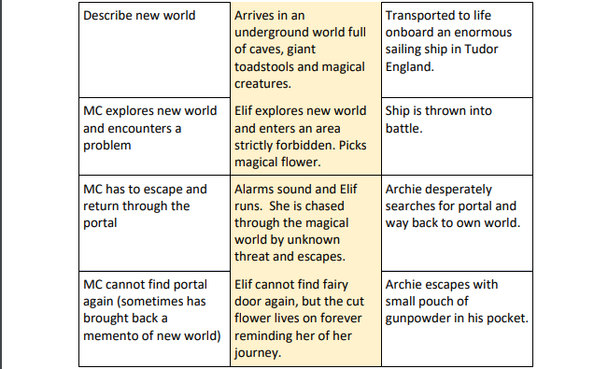
Using this underlying pattern, plan a portal story of your own. You may like to draw upon your own personal experience as well as your wider reading and imagination. Perhaps the portal takes you into an iron age dwelling.
I have also included two pictures in case they help you.
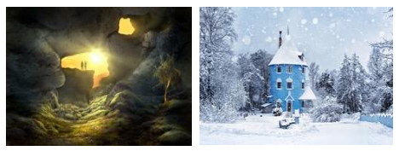

Make notes/brainstorm words, phrases and ideas that you could include.
Thursday 21st May
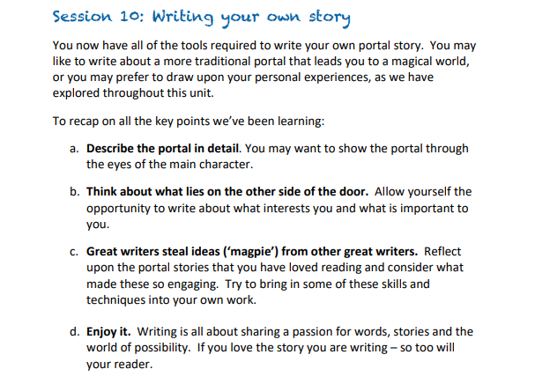
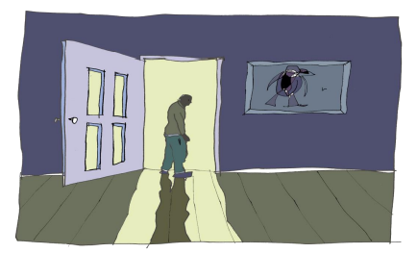

Now write your portal story, drawing on all that you have learned. Don’t forget to email your work – great writing deserves an audience!

