Goldfinch English – Home Learning tasks - Week Beginning 1st June 2020
Don’t forget to scroll down to find the resources for this 2 week unit.
Monday  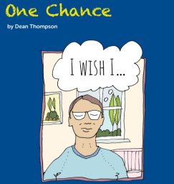 | Be careful what you wish for.  Think about the positives and negatives of having a wish granted.  Email your sentences to Mrs Wirth
Tuesday | The Mirror of Wishes  Copy the pattern of the poem to create your own poems.  Email your poem to Mrs Wirth
Wednesday | One Chance  Predict what will happen next in the story  Email your prediction to Mrs Wirth
Thursday | One Chance  Investigate powerful language and its use in the text.
Friday  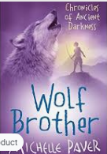 | Reading Comprehension – Wolf Brother by Michelle Paver  Make sure you have listened to all the chapters from last week before you start today’s lesson.  https://wke.lt/w/s/BxFWa9  Download this week’s Reading Journal on the link and email your task for Mrs Stangroom.
Monday 1st June
“Be careful what you wish for, you may receive it.” – anonymous
If you had just one chance to make a wish, what would you wish for? Brainstorm some ideas. For example, I might wish for a new car, a dog or a yacht. Or to be a world-famous footballer or not to have to go to school! (Hmmm)
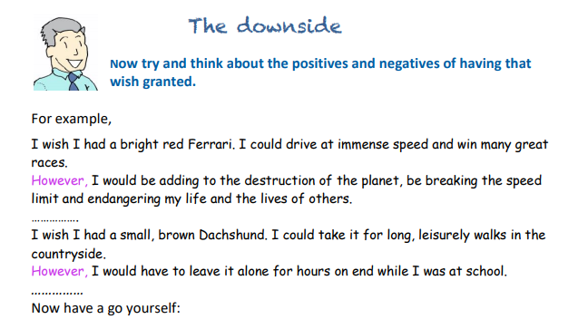
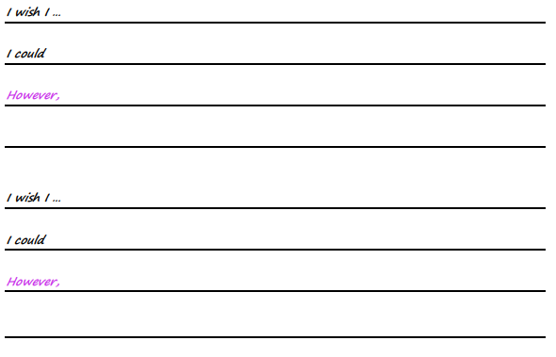
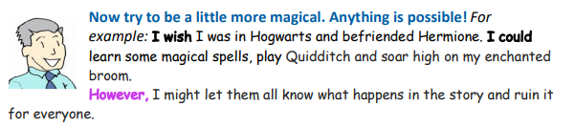
I wish I … ___________________________________________________

I could…_____________________________________________________

However… ___________________________________________________
___________________________________________________________

I wish I … ___________________________________________________

I could…_____________________________________________________

However… ___________________________________________________
___________________________________________________________

Tuesday 2nd June
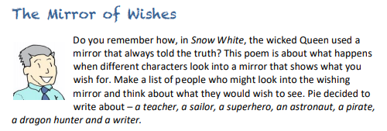
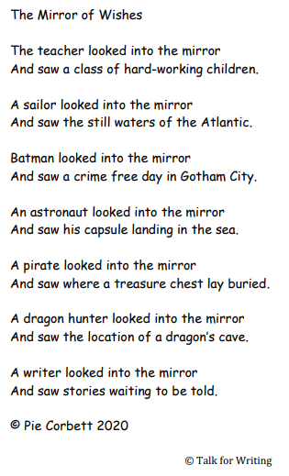
As you can see, he has written each idea using the same pattern, based on two lines. Copy his pattern but use your own characters and ideas about what they might wish for. Write your poem in your notebook or in the space below .
The Mirror Of Wishes


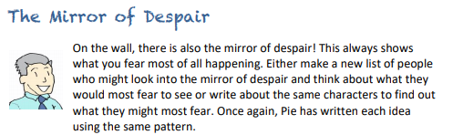
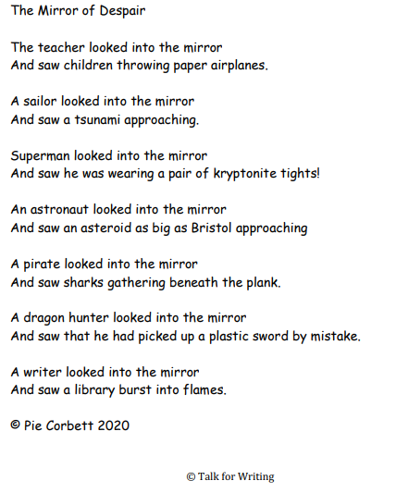

Try copying his pattern again but use your own characters and ideas about what they might most hate to have happen in their lives. Write your poem in your notebook or in the space below. Decide which of your poems you like the best and email it to Mrs Wirth.
Mirror of Despair
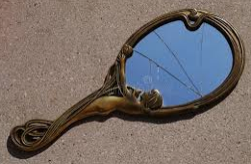

Wednesday 3rd June 2020
One Chance
Outside, the evening was cold and wet. A squally wind howled, rattling the roof tiles and shaking the window frames of 13 Wager Road. Inside, shabby curtains were drawn, a humble fire crackled and a couple sat in silence. Jack stretched out on the tired couch with an amused smile, turning the page of his favourite novel. Sarah scowled, silently seething. She scanned the room, noticing the worn-out furniture, peeling paint and, in her opinion, a pointless, idle husband. She deserved so much more than this. Suddenly, the letterbox jangled and there was a solitary but decisive knock on the door. Hope, the Labrador, barked. Sarah pulled back the curtain and watched as a hooded figure slipped silently away up the road. Puzzled, she stared down at a golden card that had appeared, glinting on the frayed doormat. Tentatively, she gathered it up and read it out loud:
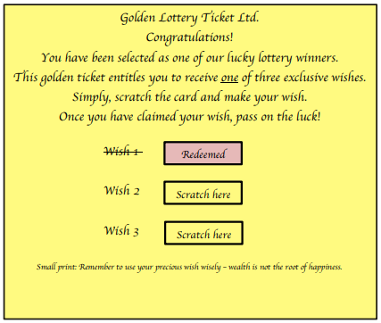

What next? We’ve stopped at an interesting part of the story. Summarise below what you think could happen next.
Email your answer to Mrs Wirth
_______-__

Thursday 4th June
Now let’s find out how close your predictions were yesterday. Read on!

Sarah gasped. This is just what she was looking for – another chance. Maybe lose the idle husband as well, she thought, shaking her head.
“I am going to give this a go. I am thinking lots of money to buy expensive clothes and maybe you can finally sort this house out,” she said to Jack, rummaging desperately in the drawer for a coin.
“Utter nonsense,” muttered Jack, glancing up from his book and taking in the room. “I love this old house and you just the way you are. Even if all that did come true, there’ll be a catch. No one gets something for nothing. Just throw it away.”
Sarah stopped and nodded sullenly. He was right. She made to throw the ticket on the fire, but something stopped her. Furtively, she stashed it in her pocket.
Later that evening, as Jack slept, Sarah retrieved the ticket and greedily scratched ‘Wish 2’, dreaming of immense riches or, to be precise, £100,000. Outside, a squally wind howled. Inside, nothing happened. Bitterly, she tossed the ticket into the bin.
The next day, the wind died down to a cool, whispering breeze. Jack prepared for his early morning walk with Hope. Pulling his woollen hat firmly down over his ears, he called out to Sarah that he wouldn’t be out long and left. Sarah scowled. She could barely respond.
Eight hours passed and Sarah began to worry – where were Jack and Hope? Shaking with fear, she dialled 999, hoping for the best but fearing the worst.
A massive search was launched but there was no sign. Jack and Hope had simply vanished. Sarah was distraught. Deep down she worried if their disappearance had anything to do the golden ticket.
Days later, as the wind whipped up again, a woman in a black cloak knocked at the door. She told Sarah she had been sent to offer some compensation for her sad loss. Sarah was feeling desperate so asked, “How much?”
“Shall we say… £100,000?”
Shocked, Sarah recalled the greedy sum she had wished for. Could it be true? Had her selfish wish actually been granted? Quickly, she raced outside and rummaged desperately through the bin, trying to locate the discarded ticket. With sickening dread, she smoothed out the crumpled ticket and gasped in horror. It was true. The second wish had been redeemed.
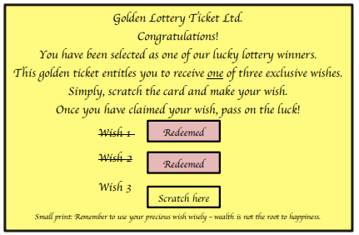
Sarah leaned against the bin for support, her head spinning, her thoughts in turmoil. Then she gathered herself together. There was still one final wish left … Could she use it to try and bring Jack and Hope back? She needed a coin, quick.
Just then, without warning, the squally wind howled and snatched the ticket from her hand. It spiralled, higher and higher like autumn leaves in a storm and then, like the mysterious woman herself, it was gone. Sarah cried out of helpless pain.
Inside, the shabby curtains were drawn and a humble fire crackled.
© Dean Thompson, 2020
What do the words mean? Have a look back at the story. See if you can work out what they mean from the context of the story and jot your ideas down here. If you are stuck, there is a list of matching words below to help you. If you are still stuck, you could ask someone else in your home to tell you, or use a dictionary or the web.


