Goldfinch English – Home Learning tasks - Week Beginning 8th June 2020
Don’t forget to scroll down to find the resources for this 3 week unit.
Monday  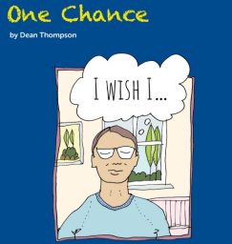 | Complete the synonym/antonym table.  Choose 4 words to include in sentences.  Email your 4 sentence to Mrs Wirth if you’re not in school.
Tuesday | Look at the text from last week. Complete the likes, dislikes, puzzles and reminders bubbles.
Wednesday | Inferring from the text.  What do these words tell you about what Sarah is like?  Email your answer to Mrs Wirth.
Thursday | Creating a mood with a ‘sentence of 3’  Email your sentences to Mrs Wirth.
Friday  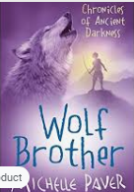 | Reading Comprehension – Wolf Brother by Michelle Paver  Make sure you have listened to all the chapters from last week before you start today’s lesson.  https://wke.lt/w/s/j0SB2g  Download this week’s Reading Journal on the link and email your task to Mrs Stangroom.
8th June 2020
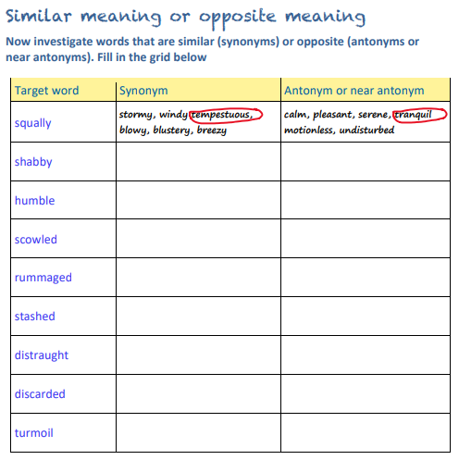
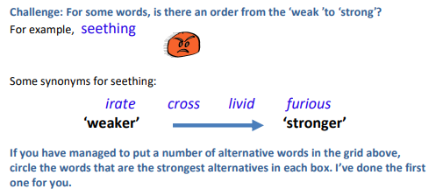

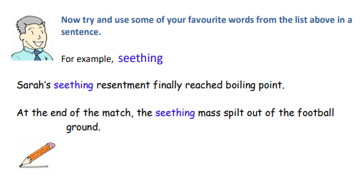
1__________________________________________________________________________________

2

3

4

Tuesday 9th June
Likes, dislikes, puzzles & surprises!
Now you have read the whole story, what did you like and dislike?
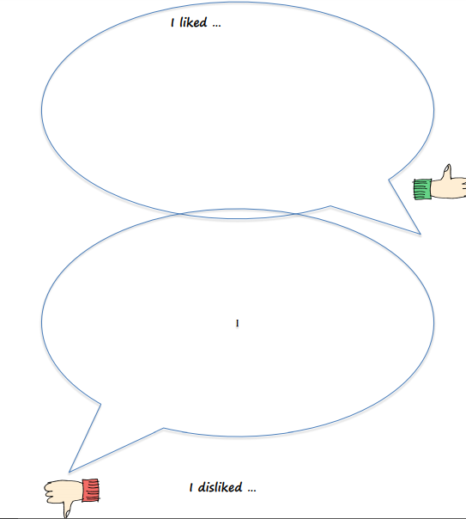

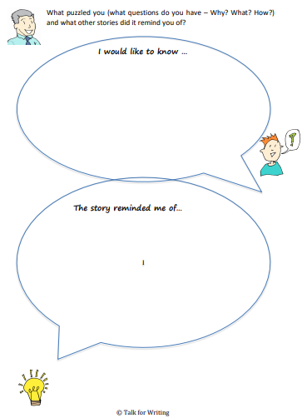

Wednesday 10th June
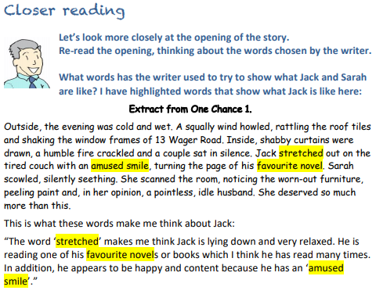
Now it is your turn. What words could you highlight that show us what Sarah is like?
Extract from One Chance 1.
Outside, the evening was cold and wet. A squally wind howled, rattling the roof tiles and shaking the window frames of 13 Wager Road. Inside, shabby curtains were drawn, a humble fire crackled and a couple sat in silence. Jack stretched out on the tired couch with an amused smile, turning the page of his favourite novel. Sarah scowled, silently seething. She scanned the room, noticing the worn-out furniture, peeling paint and, in her opinion, a pointless, idle husband. She deserved so much more than this.

What do these words tell you about what Sarah is like?
______________________________________________________________________________________________________________________________________________________________________________________________________________________________________

Extract from One Chance 1.

Outside, the evening was cold and wet. A squally wind howled, rattling the roof tiles and shaking the window frames of 13 Wager Road. Inside, shabby curtains were drawn, a humble fire crackled and a couple sat in silence. Jack stretched out on the tired couch with an amused smile, slowly turning the page of his favourite novel. Sarah scowled, silently seething. She scanned the room, noticing the worn-out furniture, peeling paint and, in her opinion, a pointless, idle husband. She deserved so much more than this.
Is there a difference between the outside and the inside?
Outside ______________________________________________________________________________________________________________________

Inside_________________________________________________________________________________________________________________
Thursday 11th June
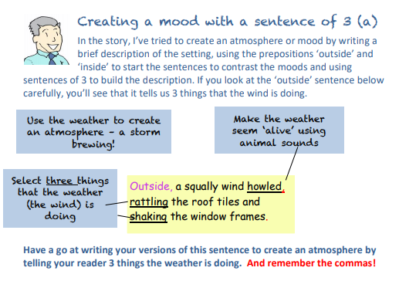
Outside________________________________________________________________________________________________________________

Outside________________________________________________________________________________________________________________

Outside________________________________________________________________________________________________________________

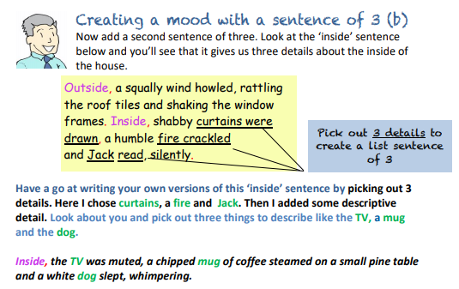
Inside________________________________________________________________________________________________________________

Inside________________________________________________________________________________________________________________

Inside________________________________________________________________________________________________________________

Email your sentences to Mrs Wirth

