Goldfinch Science Summer 2020 Week 8
Play the Powerpoint slideshow first and then complete the table below using the cards beneath the table.
What does ‘trait’ mean? __________________________________________________________________
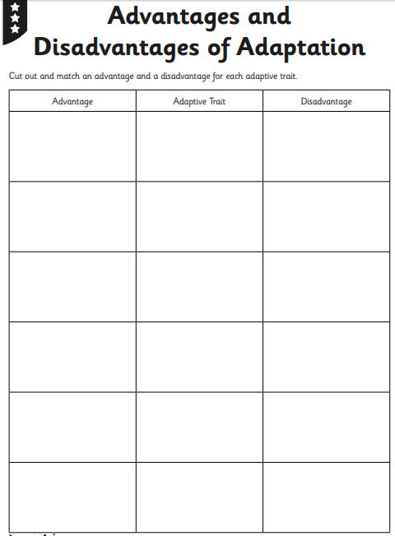
Cut out these cards and match up in groups of 3 on the table above.
(advantage, adaptive trait (the picture in the middle), disadvantage)


