Goldfinch English – Home Learning tasks - Week Beginning 15th June 2020
Don’t forget to scroll down to find the resources for this unit.
Monday  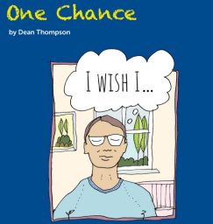 | Writing speech effectively  Email your dialogue to Mrs Wirth if you’re not in school.
Tuesday | Plan your own wishing story
Wednesday | Draft your Wishing Story  Don’t forget to read it aloud to yourself and edit for improvements.
Thursday | Publish your wishing story in a book.  Email your story to Mrs Wirth.
Friday  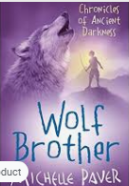 | Reading Comprehension – Wolf Brother by Michelle Paver  Make sure you have listened to all the chapters from last week before you start today’s lesson.  https://wke.lt/w/s/uYRHgS  Download this week’s Reading Journal on the link and email your task to Mrs Stangroom.
15th June 2020
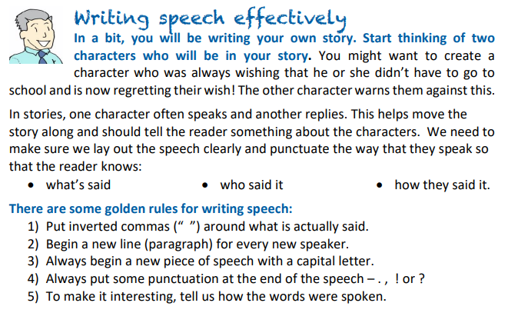
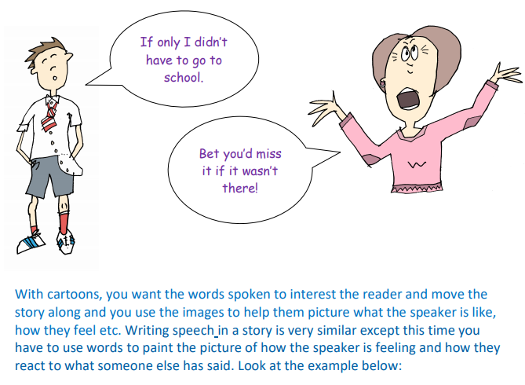
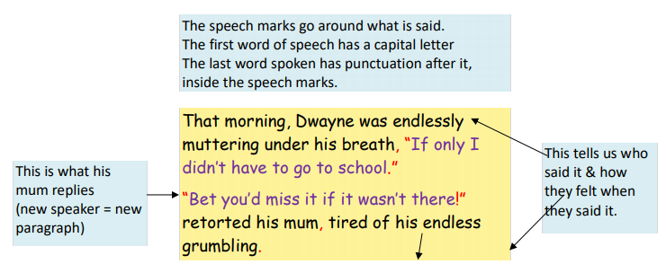
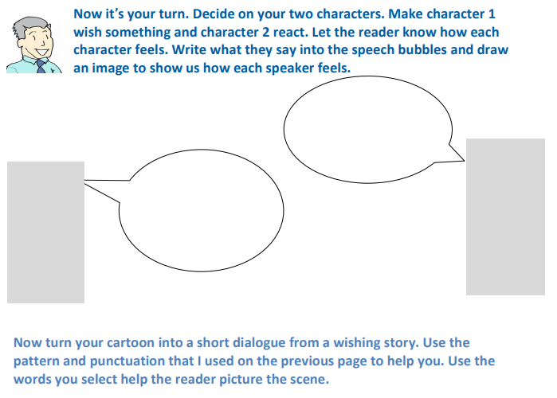
__________________________________________________________________________________________________________________________________________________________________________________________________________________________________________________________________________________________________________________________________
Tuesday 16th June
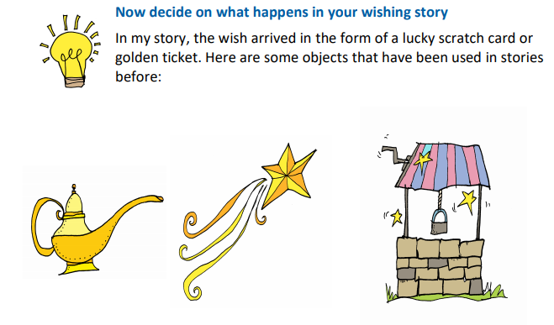
What other objects could be used?
Some ideas: you might want to pick an interesting object you could use in your story and then think about how this might arrive and how this could link to a setting and different characters.
Try to have two characters who are different. One could be cautious and be wary of the warning, the other will not, causing something else to happen that they did not expect – be careful what you wish for!
Think about the mood or atmosphere. How might you make the weather reflect the bad news that is coming?
If you want some help, try reading some other wishing tales:
Sausage Nose, a Swedish Folktale retold by Dianne de Las Casas 2008 https://professionalstoryteller.ning.com/m/group/discussion?id=1984817%3ATopic%3A18302
The Golden Touch
http://classictales.educ.cam.ac.uk/stories/metamorphoses/kingmidas/Midas_Part_1_transcript.pdf

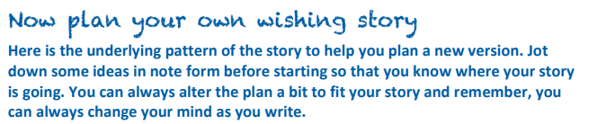
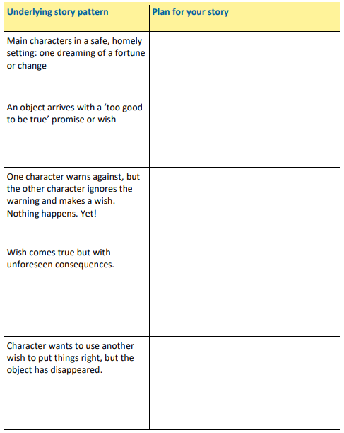
Wednesday 17th June
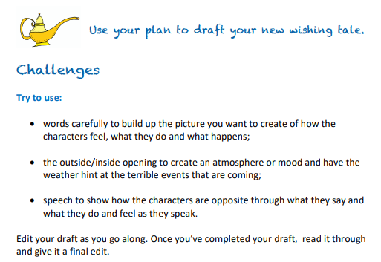

Thursday 18th June
Publish Your Story
Now that you have a new wishing tale, why not publish it? Below are some simple instructions for making a mini book from a piece of A4 paper.
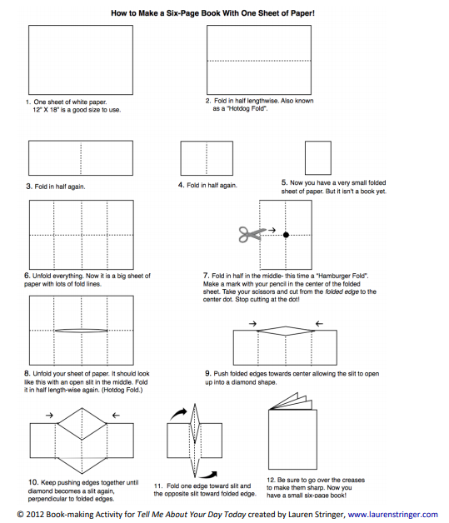
Make your book and illustrate it – enjoy!

