Year 5 answers Week Beginning 22nd June 2020
Monday
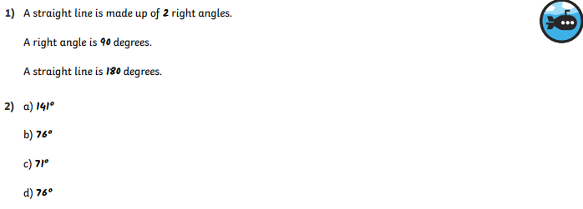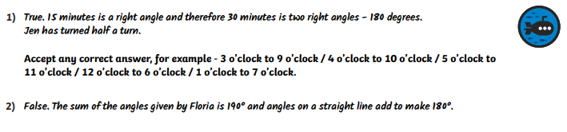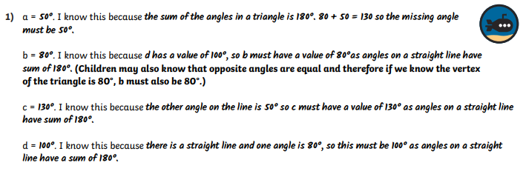
Tuesday
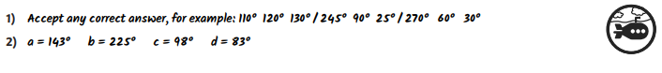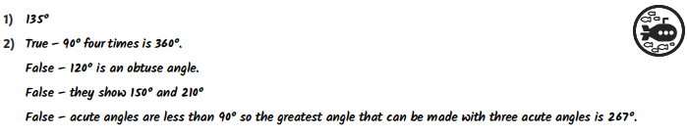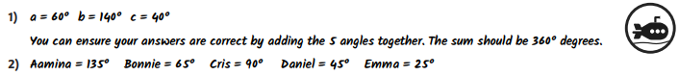

Wednesday
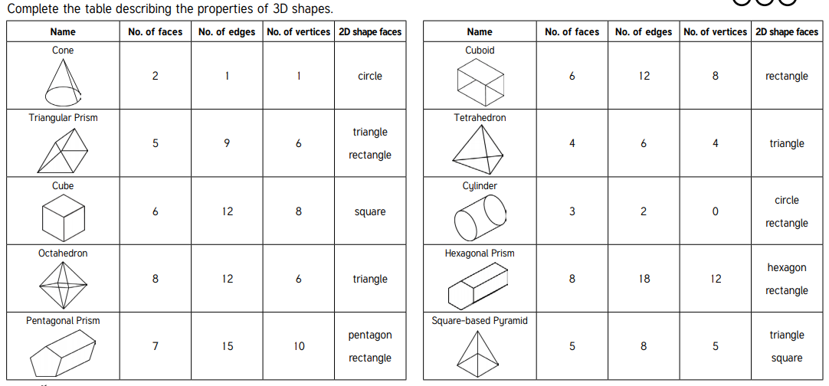

Friday – see activity sheet

