Year 5 Maths Tuesday 23rd June
Calculating Angles Around a Point
Run through the Powerpoint slide show for Tuesday to help you answer today’s questions.
You will need to know that there are 360º in a full turn:
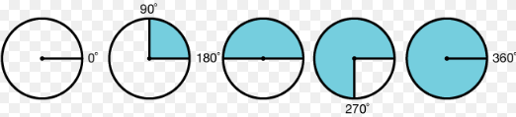
Everyone should be able to have a go at the first challenge:
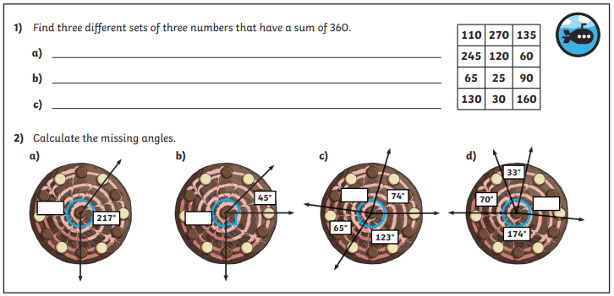
Going Deeper
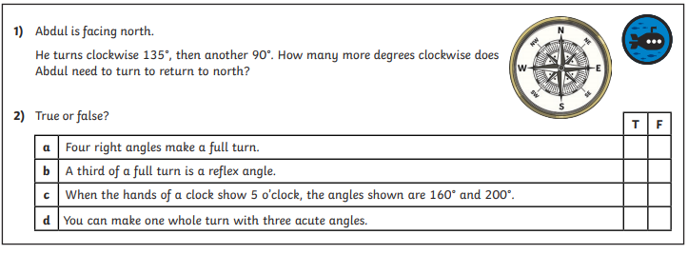

Challenge – Deep Dive
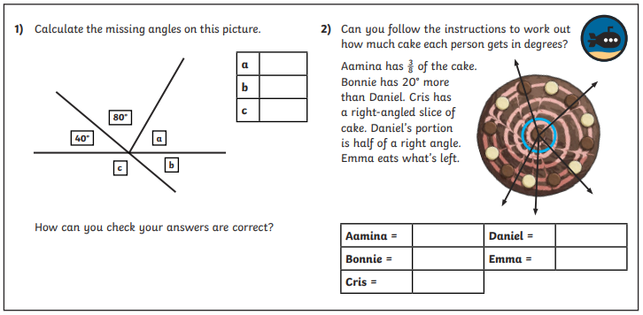

Check your answers. How did you do today?
If you made mistakes, can you explain what your mistake was?

