Year 5 Maths Monday 22nd June
Calculating Angles on a Straight Line
Run through the slide show for Monday to help you answer today’s questions.
You will need to know that there are 180º in a straight line and in a triangle:
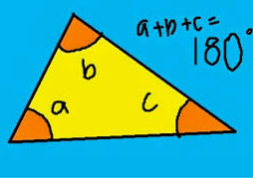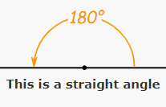
Everyone should be able to have a go at the first challenge:
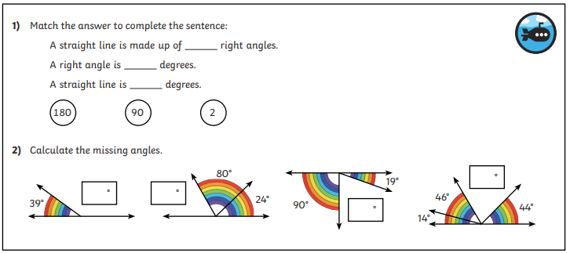
Going Deeper
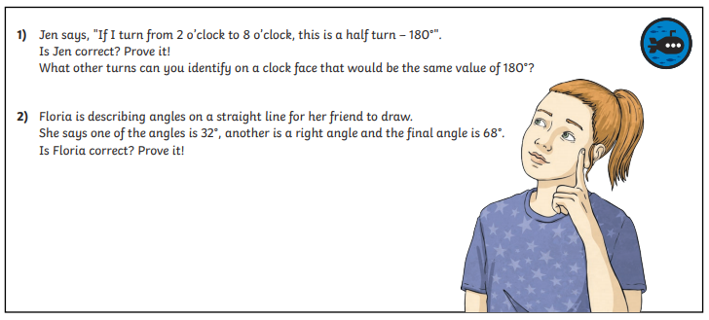
Deep Dive - Challenge
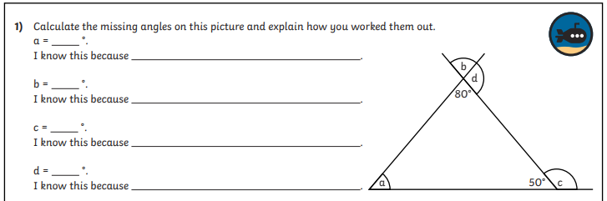

Check your answers. How did you do today?
If you made mistakes, are you able to explain where you went wrong?

