Name: 22/6/2020
Goldfinch Class are:
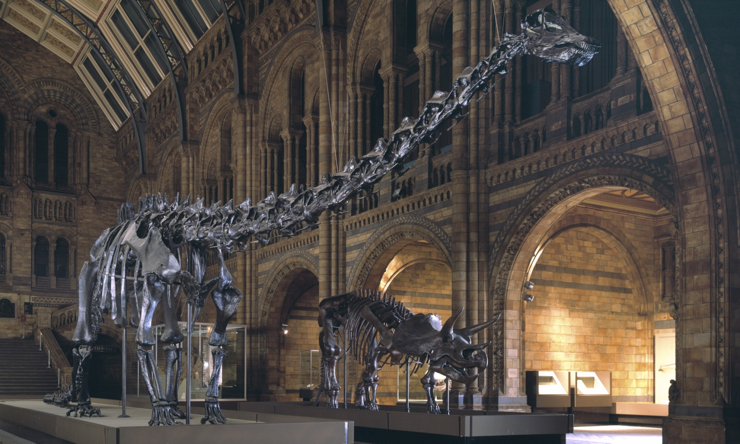

Explore the different time periods dinosaurs lived, sort the facts from the myths about why they died out, and find out what scientific research has taught us about these prehistoric giants.

Find out about TRex fossils. What did it tell us about carnivores?

What can you find out about the Iguanodon?

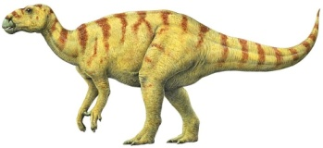
Sketch the skull of a Triceratops.

What did you learn about the Baryonyx?

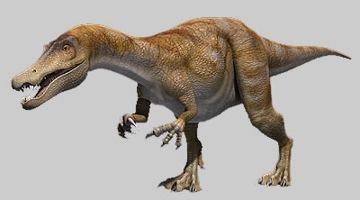

What were the three periods of the Mesozoic Era?
1.
2.
3.

What theories have scientists put forward for dinosaur extinction?

Use this space to note or draw any other amazing facts you want to record.

