Jurassic Park Dialogue
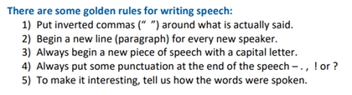 | Think about the work that you did last week on punctuating dialogue. Imagine the conversation that took place between the two scientists in the picture and the owner of Jurassic Park. Write this dialogue beneath the picture.

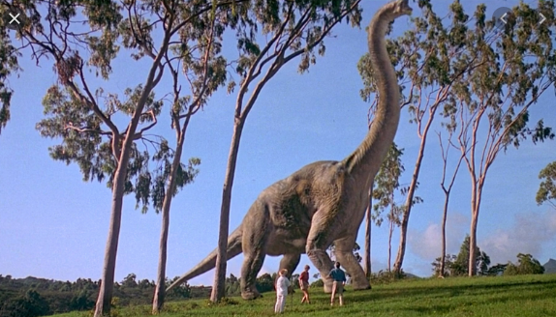
“I can’t believe what I’m seeing. How did you manage this?” the professor asked, his eyes widening in disbelief.
The owner smiled. “A mixture of luck and science. Are you impressed?”
______________________________________________________________________________________________________________________________________________________________________________________________________________________________________________________________________________________________________________________________________________________________________________________________________________________________________________________________________________________________________________________________________________________________________________________________________________________________________________________________

