Jurassic Park DADWAVERS
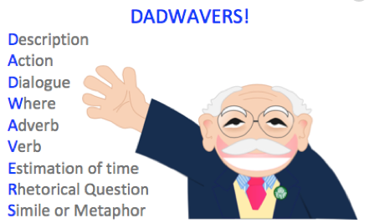 | Use ‘DADWAVERS’ to write a paragraph to describe this scene from the movie, Jurassic Park. Think very carefully how you will start each sentence in a different way to add detail and variation to your sentence structures. Each sentence should start with a different DADWAVER.




