How to plan a visit to

A tourist guide
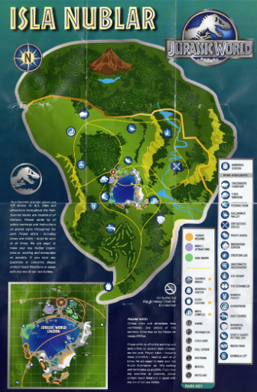

Monday 29th June
Read the model text: How To Prepare For a Kenyan Safari. This will be the model for your writing later this week. Then complete the table, explaining your thoughts about the text.
1: say what you thought about the extract and give reasons | 2: Identify features of the text that you could include in a toolkit for writing a set of instructions for preparing for a visit to Jurassic Park. | 3: Say what puzzled you, asking open ended questions Discuss your questions with your group

Read the text. Allow time to absorb ideas.
Three reasons I like the text:  1  2  3 | Three reasons I don’t like the text/think it could be improved:  1  2  3
Main features of the text  1  2  3 | Questions I would like to discuss with my group ( you could share these on the Google assignment page to discuss with each other online)

Tuesday 30th June  Design a Visitors’ Map for Jurassic Park.  You could link this to your maths project.  Clearly show the different dinosaur zones and include facilities like café, toilets and shops. | 
Wednesday 1st July
Use the model text to plan the information and instructions you will include in your own visitor guide.
Must: Use the model text to plan how to organise paragraphs?  Should: decide what text features should go in each box  Could: Think about ways of linking paragraphs. What other features could enhance your writing? |  | 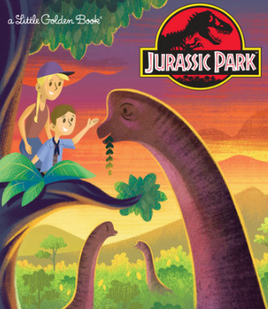
Use the Model Text and your Toolkit to ‘Box Up’ your planning
Introduction
Use positive adjectives to describe everything. Let the reader really imagine how amazing it all is.
Use rhetorical questions
Use imperative verbs

Also include hyphens, eg once-in-a-lifetime
Dashes at the end of a clause - to add information
Equipment  Start with an independent clause before the colon  Describe the things in the list so you can separate the list items with a semi colon | .
Step by step instructions
Use bullet points
Adverbials for time fo9llowed by a comma
Imperative verbs
Use subordinating clauses to give reasons e.g because, since, although
Remember brackets to add parentheses ( extra info not a complete clause)
Use a semi colon to link two independent clauses
Hyphenated words

Conclusion
Explain why visitors should follow the instructions
Use apostrophes such as ‘must-see’
Brackets, dashes and commas for parentheses
Passive voice

Thursday 2nd July
How to Prepare for a Visit to
Jurassic Park.

You may wish to type up your instructional guide here or make a brochure by folding a piece of A4 into 3 like a real brochure that folds out. It’s up to you. If you make a brochure, you can upload the file if you did it digitally, or send a photo if you made it by hand. The choice is yours. You might want to include pictures and maps too.
________________________________________________________________________________________________________________________________________________________________________________________________________________
________________________________________________________________________________________________________________________________________________________________________________________________________________
________________________________________________________________________________________________________________________________________________________________________________________________________________
________________________________________________________________________________________________________________________________________________________________________________________________________________
________________________________________________________________________________________________________________________________________________________________________________________________________________
________________________________________________________________________________________________________________________________________________________________________________________________________________
________________________________________________________________________________________________________________________________________________________________________________________________________________
________________________________________________________________________________________________________________________________________________________________________________________________________________
________________________________________________________________________________________________________________________________________________________________________________________________________________
________________________________________________________________________________________________________________________________________________________________________________________________________________
________________________________________________________________________________________________________________________________________________________________________________________________________________

