Goldfinch Topic Activities 6th - 17th July 2020
Below are all the activities for you to complete in your own time over the next two weeks. The year 6 will also be spending a few days on their cycling proficiency so spreading the activities out over two weeks gives everyone a bit more flexibility.
English/History 1   | This week you are going to make your own interactive book about this term’s topic on prehistory. This task will take you quite a while if you do it properly so this is your main English task for the fortnight too.  https://wke.lt/w/s/bpK1XC  Turn in your book (as a document or photos) onto Google Classrooms if you can By 17th July or sooner.
Reading  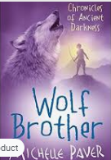 | Reading Comprehension – Wolf Brother by Michelle Paver  Make sure you have listened to all the chapters from last week before you start the last 2 lessons.  Lesson 10 https://wke.lt/w/s/K40oBi  Lesson 11 - https://wke.lt/w/s/gT5DzL  Submit your tasks on Google Classrooms if you can by 17th July.
History 2  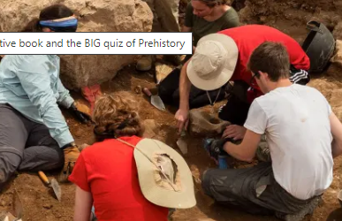 | Once you have completed your interactive book, then it's time to really show off that knowledge in the Big quiz of Prehistory on Kahoot. Details are all on the link below.  https://wke.lt/w/s/1o1Wma
PSHE  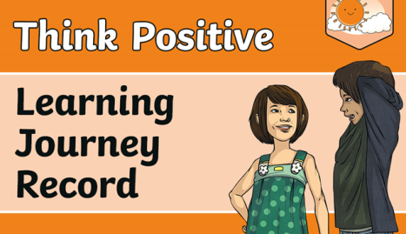 | Y6 will complete work in school  Go to the link for  Goldfinch PSHE Think Positive - Learning Journey WC 6 7 2020  Activity - see sheets below
Maths  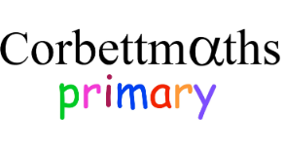 | Time to revise your work from this year. Go to:  https://corbettmathsprimary.com/5-a-day/  And choose a task for the 6th- 17th July.  You decide the level of challenge you wish to try but I would recommend bronze, silver or gold for Y5 and silver, gold or platinum for Y6.  When you have finished the tasks, check your answers at  https://corbettmathsprimary.com/2018/05/30/5-a-day-july-answers/
Y5 PSHE | Keep working on your transition packs for the picnic on Monday 13th July. Think carefully about your prefect application form, and complete your transition booklet too.
Sport  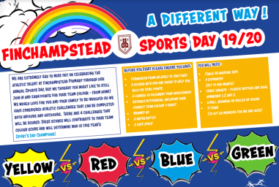 | Take part in the Virtual Sports’ Day  Follow the instructions on the attached file to join in with the Finchampstead School Virtual Sports Day. You must email your results (information is at the end of the sheet) to finchparents@finchampstead.wokingham.sch.uk  By Friday 17th July.
Design a Jurassic Park Fairground Ride  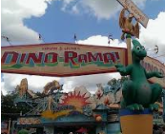 | You've ordered the dinosaurs, planned the attractions, hired the staff and designed the diner menus. You've drawn maps and written visitor guides. All that remains is for you to build a fairground ride for your theme park.  It could move horizontally like a carousel or on a vertical plane like a Ferris wheel. Look at the YouTube clips on Google Classrooms to get some ideas. Some are more advanced than others depending on what resources you have available. These are the only clips that we recommend. If your parents agree, you could look at other examples too. Use any thing that you have around your home: recycling junk modelling resources, Lego, Meccano, K-Nex etc. Be as creative as you want.  The only brief is that it must be Dinosaur themed. You have two weeks to complete this project.
Daily TTRS 10mins   | Play for at least 10 minutes every day.  Can you achieve Rock Legend or Rock Star status?  Send us a screen shot of your avatar, showing us what accessories you have bought with the coins that you have earnt this week.
Daily French 5-10mins  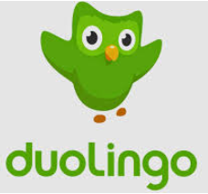 | Who was the winner? Send us a screenshot of your home screen (preferably on Google Classroom for this week’s assignment) showing how many crowns you have earned for French.  The deadline is Friday 10th July. The winner will be announced on Monday 13th July.  The prize is a French boules set known as Petanque.  What can you find out about petanque?
Daily Reading 15mins   | Go to readtheory.org/auth/login and login with your new usernames and password. It’s great to see that most of you have been able to logon and are successfully improving your reading.  Aim to spend about 15-20 minutes - 4 times a week to read and complete the quizzes .
Plan a Picnic | See the activity list below for ideas on healthy eating and planning a picnic for your family.
THINK POSITIVE Goldfinch Activity Sheet - July 2020
What are your goals for future learning?
These could be something you would like to do or do better, something you would like to learn more about, or something new that you would like to discover.
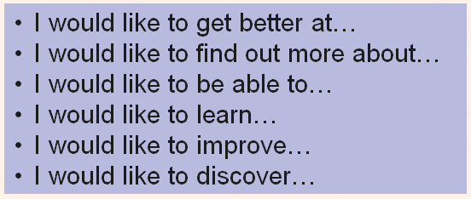
- ____________________________________________________________________________________________________________________________________________________________________________________________________________________________________________________________
- ____________________________________________________________________________________________________________________________________________________________________________________________________________________________________________________________
- ____________________________________________________________________________________________________________________________________________________________________________________________________________________________________________________________

Describe how you feel about your learning about positive thinking and why.

Is there anything you would like to ask or tell us about Positive Thinking? This could be about your learning, about Positive Thinking in general, or something about Positive Thinking in your life.

How can you apply positive thinking to your learning at home, at school or in the wider world? Give examples.
____________________________________________________________________________________________________________________________________________________________________________________________________________________________________________________________________________________________________________________________________________________________________________________________________________________________________________________________________________________________________________________________________________________________________________________________________________________________________________________________________________________________________________________________________________________________________________________________________________
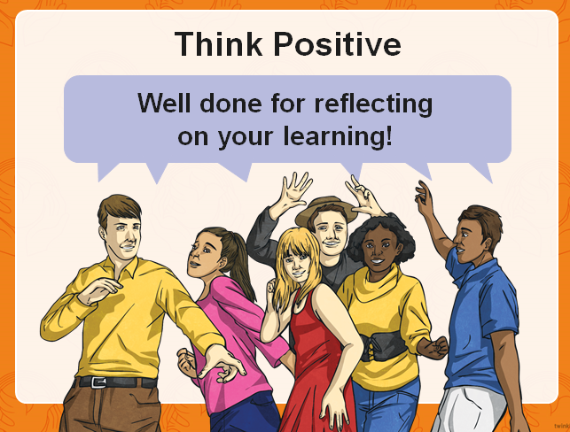

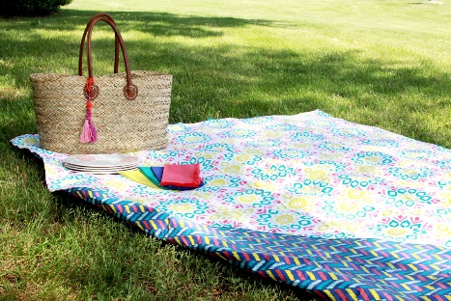
Picnic Challenge – Can you plan a picnic?
You can do these challenges in any order. You may choose to do all of them or just a couple. The choice is yours but each one will help you to learn something new. After you’ve completed them, reflect on how you used the 5R’s or the school values to help you learn. Which was your favourite activity and why?
- Watch these short clips on healthy eating before planning a picnic. Plan what food you will need. Where will you eat? Who are you catering for?
https://www.bbc.co.uk/bitesize/topics/zrffr82/articles/zppvv4j
https://www.bbc.co.uk/bitesize/topics/z4d82hv/resources/1

- Can you design a poster of healthy diet choices?

- Make a collage of your favourite healthy foods – use old magazines or draw items or both.

- Can you find a healthy food from each continent? Challenge – take one continent then find a healthy food from each country on that continent. Which is your favourite and why?

- If you do have a picnic, in your garden or elsewhere, can you take a photo or draw a picture of it then write a short recount as a memory of the event? Use all the writing skills you’ve covered in lockdown to help you.

